

**Java institute for Advanced Technology**

Department of Examinations

**RESEARCH ASSESSMENT**

|  |  |
| --- | --- |
| COURSE(S) – (LEADING TO) | PROFESSIONAL GRADUATE DIPLOMA IN SOFTWARE ENGINEERING |
| UNIT NAME | WEB ENGINEERING 01 |

|  |  |  |
| --- | --- | --- |
| **NAME** | **:** | **Y.M. CHAMOD MADUWANTHA** |
| **NIC** | **:** | **200022402104** |
| **SCN NO** | **:** | **207977764** |

**Header**



This is the main header user can see in web application. When user don’t log into the site header will show only home, sign up and sign in. when user log into to their account and header will display home, booking, profile and logout sections. When doctor also can log into the account when doctor log in the account also user can see home, appointment, profile and logout.

When user log into their account,

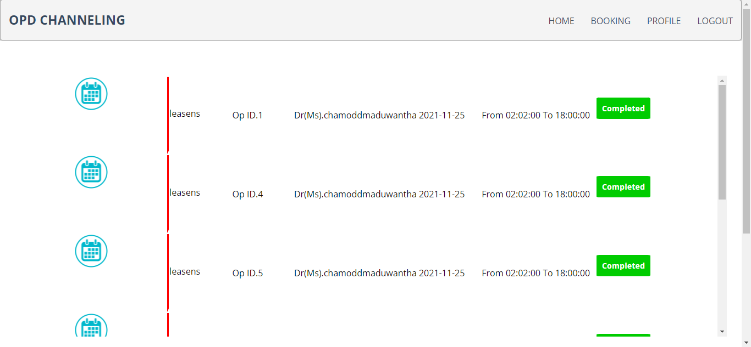

When doctor log into the account,



When admin login to the admin panel admin can see different section. Below show admin nav bar,

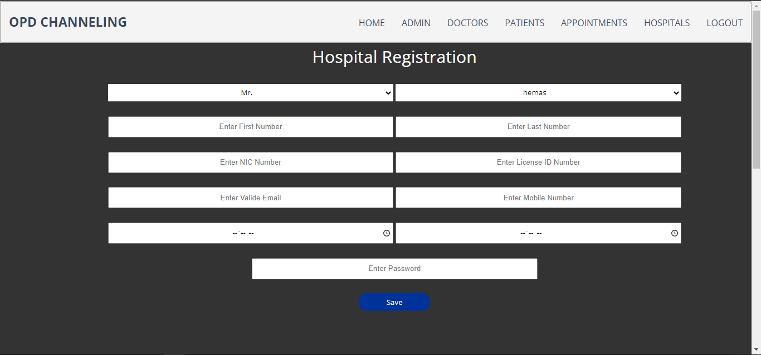

**Footer**



This is web application footer. It includes company name, address, contact number, their website name and also view about this ABS software solutions company and social media links. Footer is include all system available pages

**Login Page**

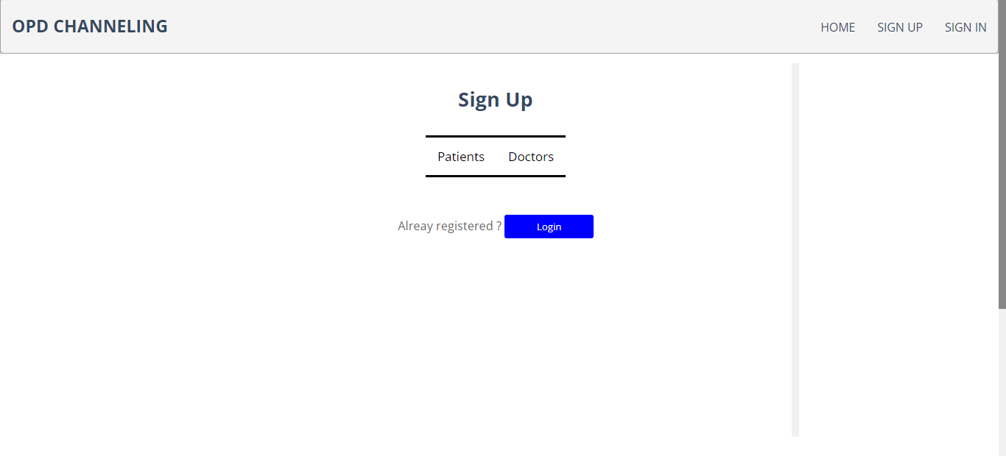



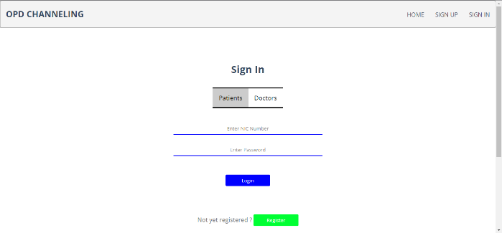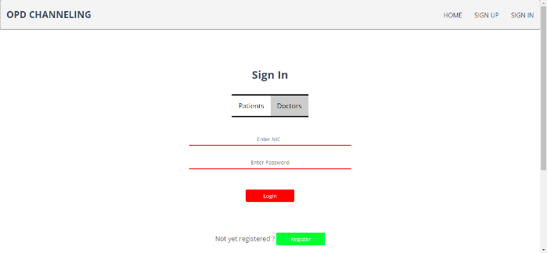

In this application their three types of users are logging into this system they are admin, patients and doctors to this function when user go the sign in page user can select tow type of login they are patient and doctor section. When patient section can login patients and admin can login into application and doctor section only can login registered doctors. If patient and doctor if not registered and they can click sign up button to move to sign up page

**Sign Up page**



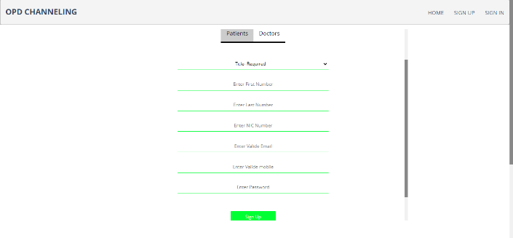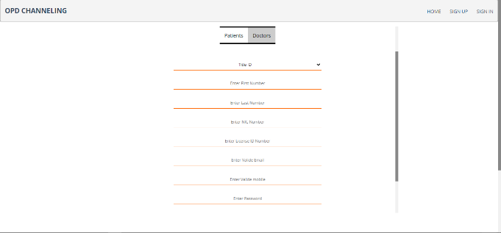

In this section also have two section for patient registration and doctor registration in patient section user have to fill (title, first name, last name, NIC number, email, mobile and password) and doctor section doctor must fill(title, first name, last name, NIC number, doctor license number, email, mobile and password ). If user already registered and user can click login button to move to the login page

**Home page**

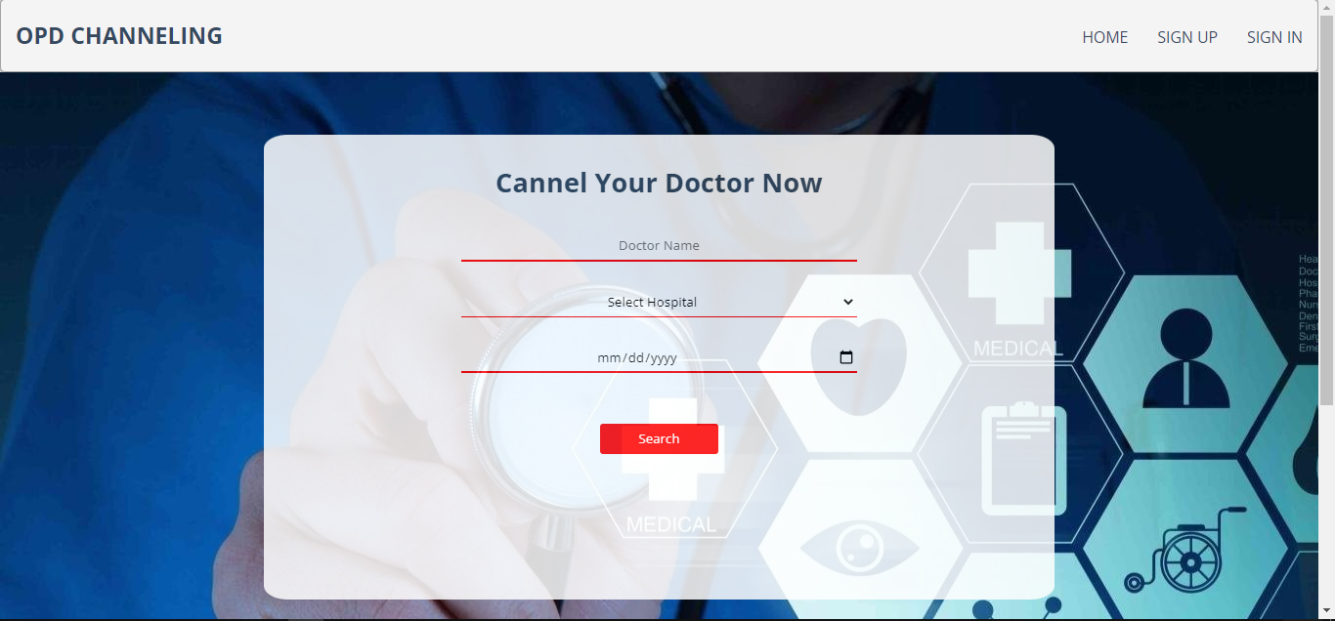

This is the index/ home page of this web application when unregistered user came to the site user can search doctor name, hospital, and appointment date and click search button shows related search result to the user and unregistered user click channel button he move to the home page in show massage “please login into the account or created an account” but doctor login into the account doctor can not search channel the search button will disable when doctor login. User must have input channelling hospital and appointment date to search data and doctor name is not compulsory to search data.

**User Profile page**

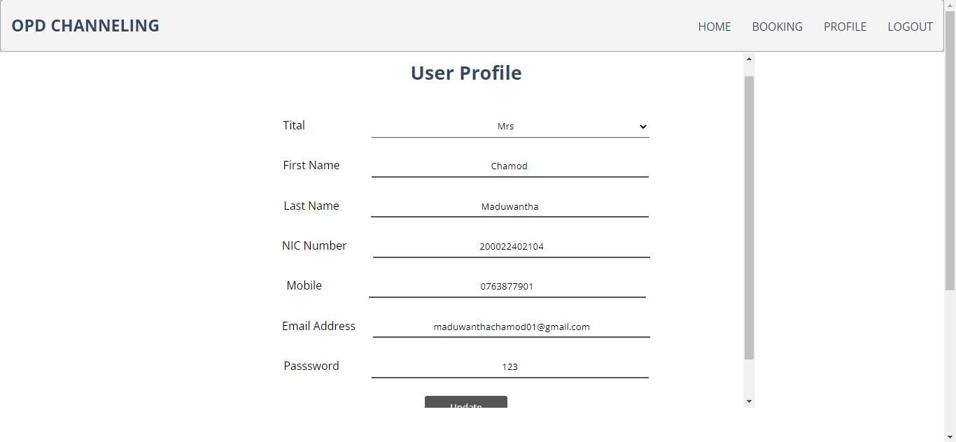

After login to the site and when move to the profile page if patient log into the account patient can see his/ her registered details and also can update their entered data. Patient can update (title, first name, last name, NIC number, email, mobile and password) and when doctor move the profile page doctor can see ((title, first name, last name, NIC number, doctor license number, email, mobile and password) and additionally doctor can entered start and end working time and working hospital.

**Search Result Page**

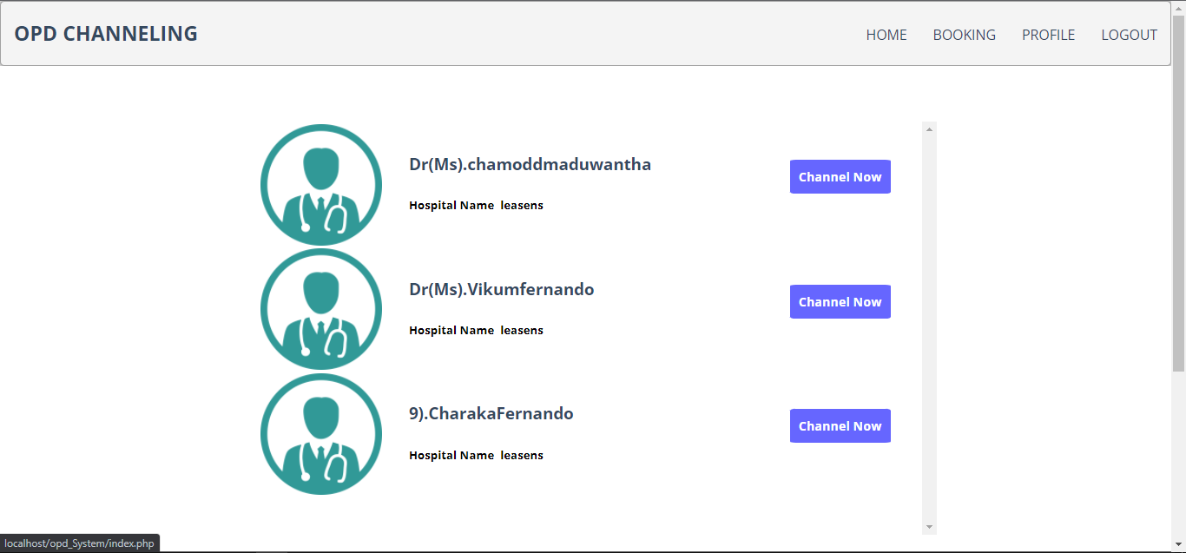

After patient entered doctor name (not compulsory), hospital name and channel date the related result will show in this page and user can see doctor name and doctor working hospital name and patient can move to the channel page after click channel now button.

**Appointment Page**

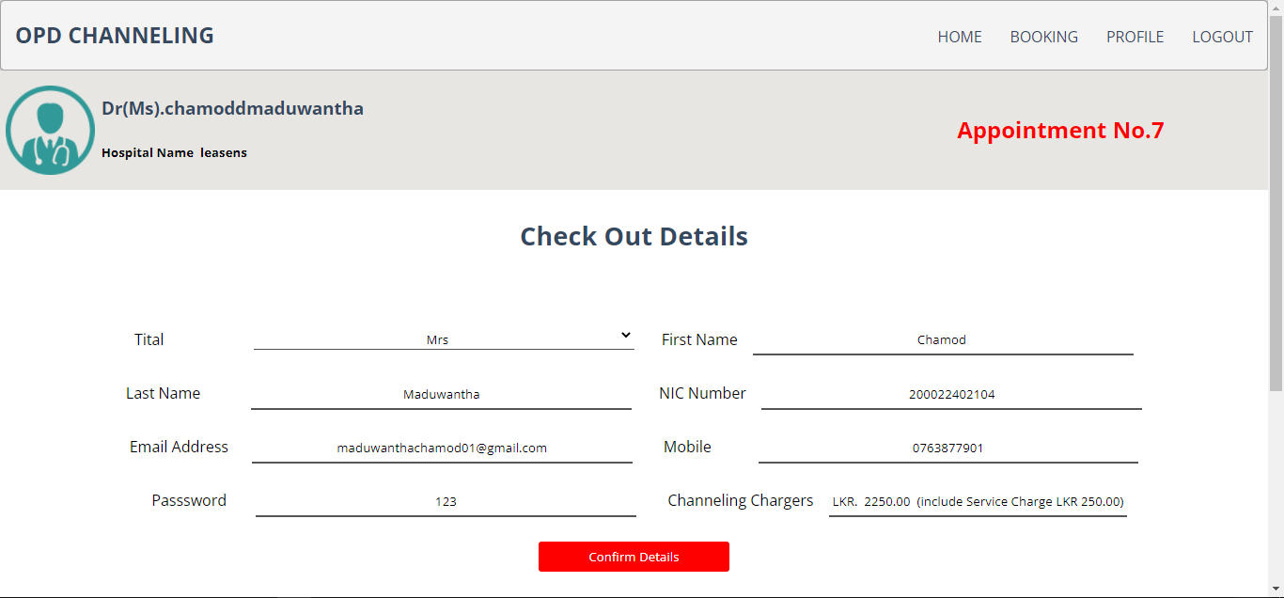

After click channel now button user move to the appointment page and user can see doctor details and patient details and channel charges and current available appointment number will show to the patient and all information are current can click confirm details button appointment record will save to the system

**Appointment Booking page**

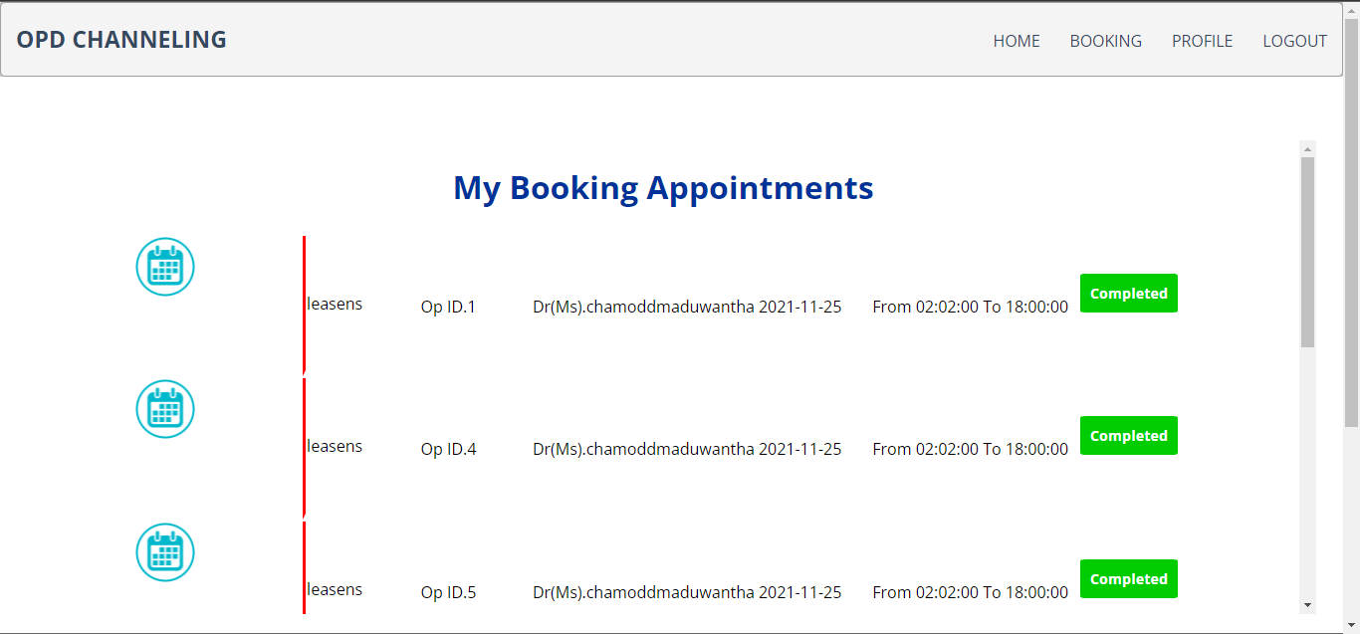

When set the appointment and patient can see their set appointments when move to the booking page and user can see schedule hospital name, his/her appoint id number, doctor name, date and time. Patient can complete patient channel and click completed button appointment will disable.

**Doctor Appointment Page**

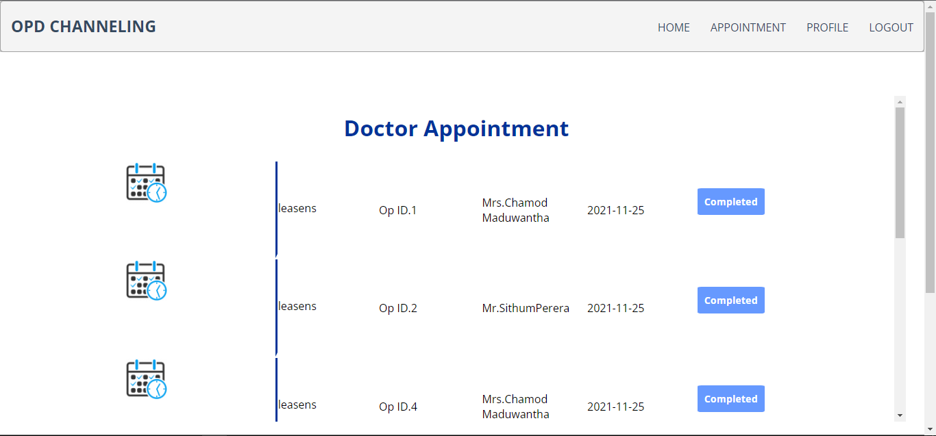

Doctor can see his/her schedule appointments in appointment page and doctor can see hospital name, appointment number, patient name and date and click completed button this appoint will complete and disable this appointment.

**Admin Section**

**Admin page**

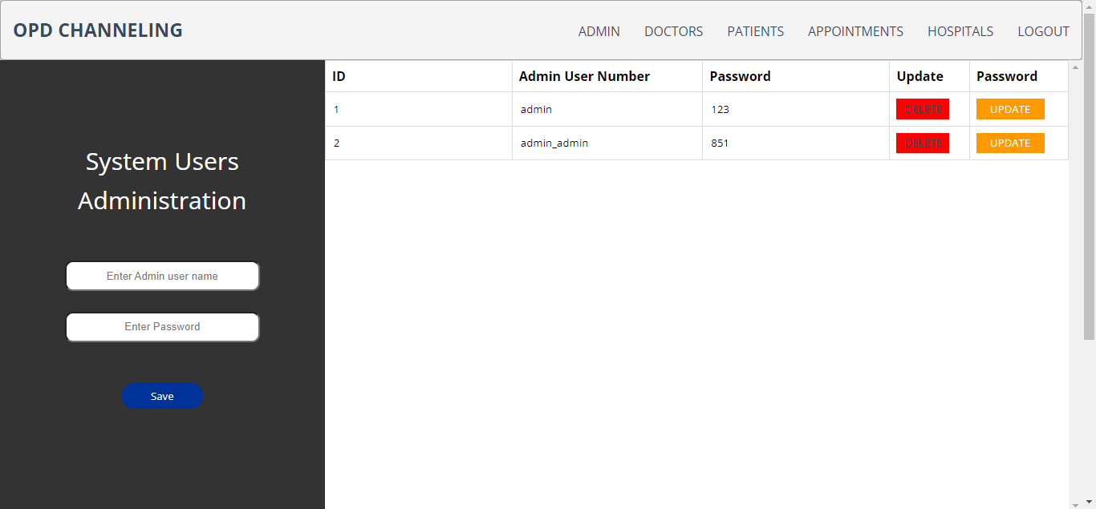

This page can insert new admin users in this application. It required user name and password and user can updated insert data and can remove the insert users.

**Doctors Page**



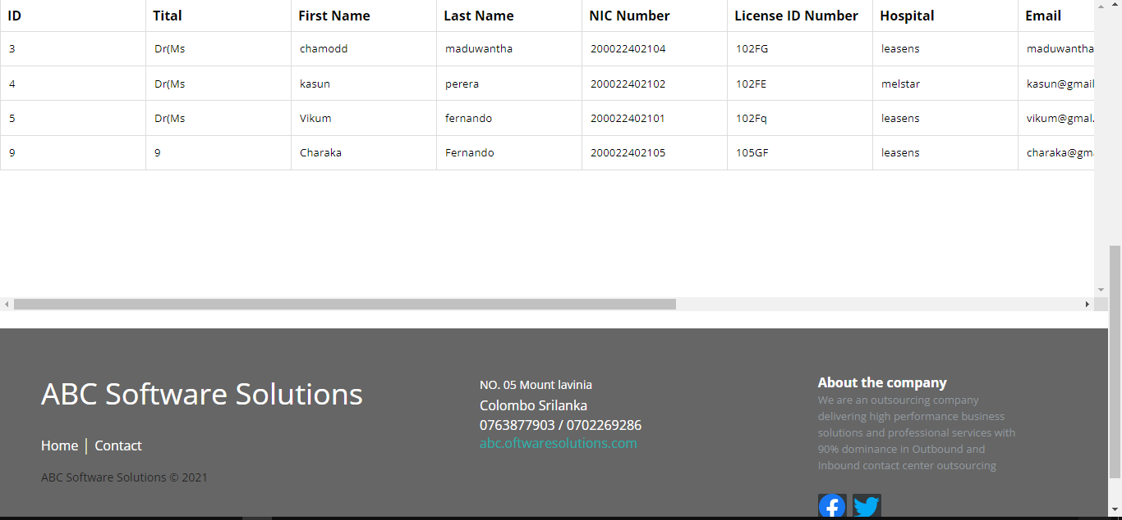

Hospital registration page admin user can register new doctor to the system and also admin user can update already registered doctors’ details in this admin sections.

**Patients page**

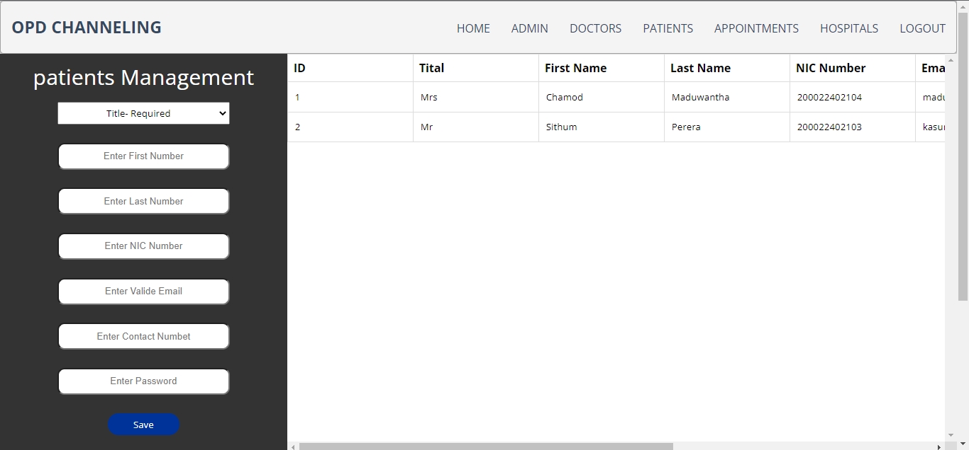

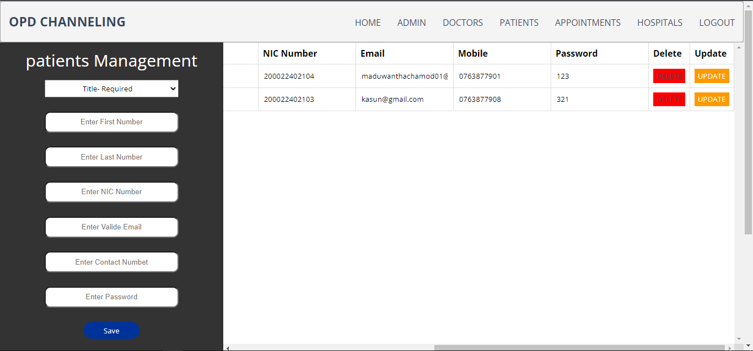

Admin patient page admin user can insert new user to the system and also view system registered patients details and change their detail and admin user can remove registered patients form the system

**Appointments page**

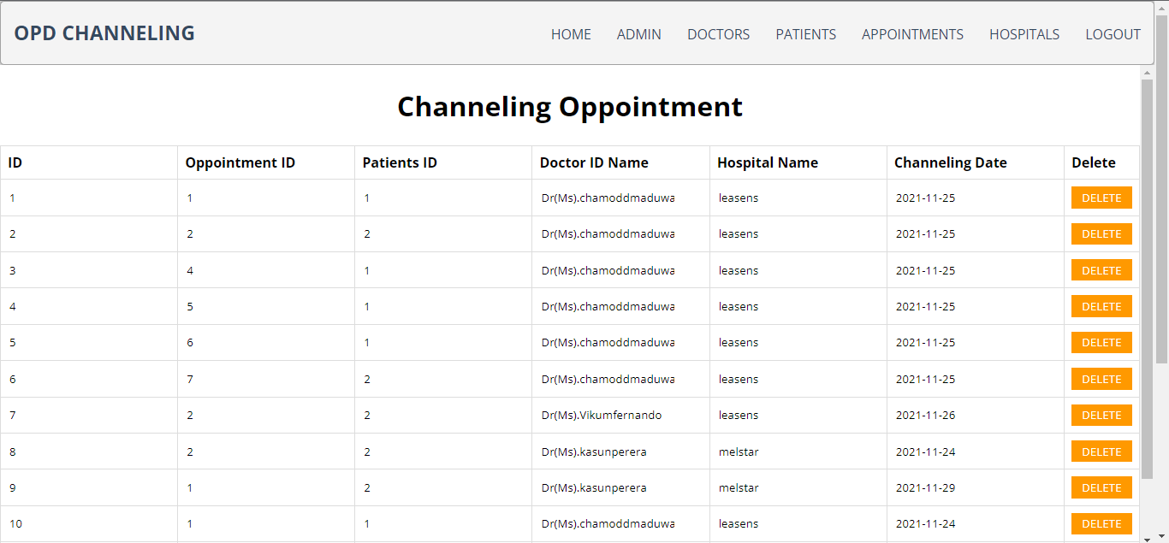

Admin user can see already set all appointments through this application and see appointment numbers, patients ID number, doctor name, hospital and channel date and this page admin only can delete set appointment in this table.

**Hospital page**

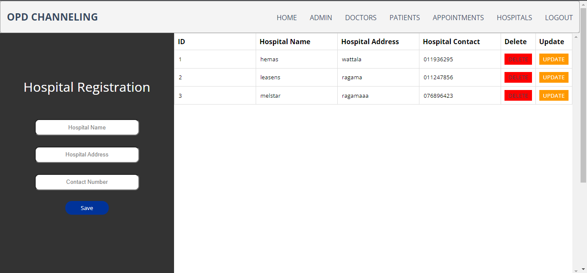

Only this page can insert new hospital to the application and using hospital name, address and contact number and user can update and delete already registered hospital information from this application

**Source Code**

**Header.php**

<?php

if (session_id() == '') {

session_start();

}

$is_login = false;

$usertypevalue="";

if (isset($_SESSION["is_Login"])) {

$is_login = $_SESSION["is_Login"];

}

if (isset($_SESSION["usertype"])) {

$usertypevalue = $_SESSION["usertype"];

}

?>

<html>

<head>

<meta charset="UTF-8">

<title></title>

<link type="text/css" href="header_css.css" rel="stylesheet"/>

<script src="headerjs.js"></script>

</head>

<body>

<header class="header">

<h1 class="logo"><a href="index.php">OPD CHANNELING</a></h1>

<ul class="main-nav">

<li><a href="index.php">HOME</a></li>

<?php

if ($is_login) {

if($usertypevalue==0){

?>

<li><a href="user_oppintment.php">BOOKING</a></li>

<?php }elseif ($usertypevalue==2) {?>

<li><a href="doctor_oppintment.php">APPOINTMENT</a></li>

<?php } ?>

<li><a href="user_profile.php">PROFILE</a></li>

<li><a href="logout.php">LOGOUT</a></li>

<?php } else {

?>

<li><a href="test.php">SIGN UP</a></li>

<li><a href="loginpage.php">SIGN IN</a></li>

<?php } ?>

</ul>

</header>

</body>

</html>

**Header.css**

* {

box-sizing: border-box;

}

body {

font-family: 'Montserrat', sans-serif;

line-height: 1.6;

margin: 0;

min-height: 100vh;

}

ul {

margin: 0;

padding: 0;

list-style: none;

}

h2,

h3,

a {

color: #34495e;

}

a {

text-decoration: none;

}

.logo {

margin: 0;

font-size: 1.45em;

}

.main-nav {

margin-top: 5px;

}

.logo a,

.main-nav a {

padding: 10px 15px;

text-transform: uppercase;

text-align: center;

display: block;

}

.main-nav a {

color: #34495e;

font-size: .99em;

}

.main-nav a:hover {

color: #718daa;

}

.header {

padding-top: .5em;

padding-bottom: .5em;

border: 1px solid #a2a2a2;

background-color: #f4f4f4;

-webkit-box-shadow: 0px 0px 14px 0px rgba(0,0,0,0.75);

-moz-box-shadow: 0px 0px 14px 0px rgba(0,0,0,0.75);

box-shadow: 0px 0px 14px 0px rgba(0,0,0,0.75);

-webkit-border-radius: 5px;

-moz-border-radius: 5px;

border-radius: 5px;

}

/* =================================

Media Queries

==================================== */

@media (min-width: 769px) {

.header,

.main-nav {

display: flex;

}

.header {

flex-direction: column;

align-items: center;

.header{

width: 80%;

margin: 0 auto;

max-width: 1150px;

}

}

}

@media (min-width: 1025px) {

.header {

flex-direction: row;

justify-content: space-between;

}

}

**Admin nav bar**

<?php

?>

<html>

<head>

<meta charset="UTF-8">

<title></title>

<link type="text/css" href="headerdesign.css" rel="stylesheet"/>

</head>

<body>

<header class="header">

<h1 class="logo"><a href="#">OPD CHANNELING</a></h1>

<ul class="main-nav">

<li><a href="admin_administratior.php">Admin</a></li>

<li><a href="admin_doctors.php">Doctors</a></li>

<li><a href="admin_patients.php"> Patients</a></li>

<li><a href="admin_oppointment.php">Appointments</a></li>

<li><a href="admin_hospital.php">Hospitals</a></li>

<li><a href="logout.php">LogOut</a></li>

</ul>

</header>

</body>

</html>

**Footer**

<html>

<head>

<meta charset="UTF-8">

<title></title>

<link type="text/css" href="footer_css.css" rel="stylesheet"/>

</head>

<body>

<footer class="footer-distributed">

<div class="footer-left">

<h3>ABC Software Solutions<span> </span></h3>

<p class="footer-links">

<a href="#" class="link-1">Home</a>

<a href="index.php">Contact</a>

</p>

<p class="footer-company-name">ABC Software Solutions © 2021</p>

</div>

<div class="footer-center">

<div>

<i class="fa fa-map-marker"></i>

<p><span>NO. 05 Mount lavinia</span>Colombo Srilanka</p>

</div>

<div>

<i class="fa fa-phone"></i>

<p>0763877903 /</p>

<p>0702269286</p>

</div>

<div>

<i class="fa fa-envelope"></i>

<p><a href="">abc.oftwaresolutions.com</a></p>

</div>

</div>

<div class="footer-right">

<span style="color: white">About the company</span>

<p class="footer-company-about">

We are an outsourcing company delivering high performance business solutions and professional services with 90% dominance

in Outbound and Inbound contact center outsourcing

</p>

<div class="footer-icons">

<a href=""><i><img src="image/facebook-logo-2019.png"></i></a>

<a href="#"><i><img src="image/twitter (1).png"></i></a>

</div>

</div>

</footer>

</body>

</html>

**Footer.css**

* {

font-family: Open Sans;

}

section {

width: 100%;

display: inline-block;

background: #333;

height: 50vh;

text-align: center;

font-size: 22px;

font-weight: 700;

text-decoration: underline;

}

.footer-distributed{

background: #666;

box-shadow: 0 1px 1px 0 rgba(0, 0, 0, 0.12);

box-sizing: border-box;

width: 100%;

text-align: left;

font: bold 16px sans-serif;

padding: 55px 50px;

}

.footer-distributed .footer-left,

.footer-distributed .footer-center,

.footer-distributed .footer-right{

display: inline-block;

vertical-align: top;

}

/* Footer left */

.footer-distributed .footer-left{

width: 40%;

}

/* The company logo */

.footer-distributed h3{

color: #ffffff;

font: normal 36px 'Open Sans', cursive;

margin: 0;

}

.footer-distributed h3 span{

color: lightseagreen;

}

/* Footer links */

.footer-distributed .footer-links{

color: #ffffff;

margin: 20px 0 12px;

padding: 0;

}

.footer-distributed .footer-links a{

display:inline-block;

line-height: 1.8;

font-weight:400;

text-decoration: none;

color: inherit;

}

.footer-distributed .footer-company-name{

color: #222;

font-size: 14px;

font-weight: normal;

margin: 0;

}

/* Footer Center */

.footer-distributed .footer-center{

width: 35%;

}

.footer-distributed .footer-center i{

background-color: #33383b;

color: #ffffff;

font-size: 25px;

width: 38px;

height: 38px;

border-radius: 50%;

text-align: center;

line-height: 42px;

margin: 10px 15px;

vertical-align: middle;

}

.footer-distributed .footer-center i.fa-envelope{

font-size: 17px;

line-height: 38px;

}

.footer-distributed .footer-center p{

display: inline-block;

color: #ffffff;

font-weight:400;

vertical-align: middle;

margin:0;

}

.footer-distributed .footer-center p span{

display:block;

font-weight: normal;

font-size:14px;

line-height:2;

}

.footer-distributed .footer-center p a{

color: lightseagreen;

text-decoration: none;;

}

.footer-distributed .footer-links a:before {

content: "|";

font-weight:300;

font-size: 20px;

left: 0;

color: #fff;

display: inline-block;

padding-right: 5px;

}

.footer-distributed .footer-links .link-1:before {

content: none;

}

/* Footer Right */

.footer-distributed .footer-right{

width: 20%;

}

.footer-distributed .footer-company-about{

line-height: 20px;

color: #92999f;

font-size: 13px;

font-weight: normal;

margin: 0;

}

.footer-distributed .footer-company-about span{

display: block;

color: transparent;

font-size: 14px;

font-weight: bold;

margin-bottom: 20px;

}

.footer-distributed .footer-icons{

margin-top: 25px;

}

.footer-distributed .footer-icons a{

display: inline-block;

width: 35px;

height: 35px;

cursor: pointer;

background-color: #33383b;

border-radius: 2px;

font-size: 20px;

color: #ffffff;

text-align: center;

line-height: 35px;

margin-right: 3px;

margin-bottom: 5px;

}

/* If you don't want the footer to be responsive, remove these media queries */

@media (max-width: 880px) {

.footer-distributed{

font: bold 14px sans-serif;

}

.footer-distributed .footer-left,

.footer-distributed .footer-center,

.footer-distributed .footer-right{

display: block;

width: 100%;

margin-bottom: 40px;

text-align: center;

}

.footer-distributed .footer-center i{

margin-left: 0;

}

}

**Login page**

<!DOCTYPE html>

<html>

<head>

<meta charset="UTF-8">

<title>login</title>

<link type="text/css" href="login_css.css" rel="stylesheet"/>

</head>

<body>

<?php

include './header.php';

?>

<div class="l-main-div">

<div class="sub_div">

<h3 class="h3head">Sign In</h3>

<div class="tab">

<button class="tablinks"onclick="openCity(event, 'London')">Patients</button>

<button class="tablinks" onclick="openCity(event, 'Paris')">Doctors</button>

</div>

<div id="London" class="tabcontent">

<form class="from1"method="post"action="admin_paitent_login.php">

<input class="input" type="text" name="puname" placeholder="Enter NIC Number"/>

<br>

<br>

<input class="input" type="password" name="ppassword" placeholder="Enter Password"/>

<br><br><br>

<input class="loginbt" type="submit" name="submit" value="Login"/>

</form>

</div>

<div id="Paris" class="tabcontent">

<form class="from1"method="post"action="doctor_login.php">

<input class="input1" type="text" name="duname" placeholder="Enter NIC "/>

<br>

<br>

<input class="input1" type="password" name="dpassword" placeholder="Enter Password"/>

<br><br><br>

<input class="loginbt1" type="submit" name="submit" value="Login"/>

</form>

</form>

</div>

<br><br><br>

<span class="h5head">Not yet registered ?</span> <button class="regibt">Register</button>

</div>

</div>

<?php

include './footer.php';

?>

<script>

function openCity(evt, cityName) {

var i, tabcontent, tablinks;

tabcontent = document.getElementsByClassName("tabcontent");

for (i = 0; i < tabcontent.length; i++) {

tabcontent[i].style.display = "none";

}

tablinks = document.getElementsByClassName("tablinks");

for (i = 0; i < tablinks.length; i++) {

tablinks[i].className = tablinks[i].className.replace(" active", "");

}

document.getElementById(cityName).style.display = "block";

evt.currentTarget.className += " active";

}

</script>

</body>

</html>

**Login page css**

.l-main-div{

width: 100%;

height: 88vh;

background-color: white;

display: flex;

justify-content: center;

}

.sub_div{

width: 60%;

height: 75vh;

background-color: white;

margin-top: 10vh;

align-items: center;

text-align: center;

border-radius: 5%;

/* border-width:10px;

border-color: black;

border-radius: 30px;

filter: drop-shadow(0 0 0.75rem blue);*/

}

.h3head{

font-size: 2vw;

text-align: center;

}

.h5head{

font-size: 1.2vw;

text-align: center;

color: #666;

}

.input{

width: 50%;

height: 5vh;

border-left-style: none;

border-right-style: none;

border-top-style: none;

border-bottom-color: blue;

text-align: center;

}

.input:focus {

outline: none;

}

.input1{

width: 50%;

height: 5vh;

border-left-style: none;

border-right-style: none;

border-top-style: none;

border-bottom-color: red;

text-align: center;

}

.input1:focus {

outline: none;

}

.loginbt{

height: 5vh;

width: 15%;

background-color: blue;

color: white;

border-style: none;

border-radius: 3px;

}

.loginbt1{

height: 5vh;

width: 15%;

background-color: red;

color: white;

border-style: none;

border-radius: 3px;

}

.regibt{

height: 5vh;

width: 15%;

background-color: #00ff33;

color: white;

border-style: none;

border-radius: 3px;

}

.regibt:hover{

cursor: pointer;

}

.from1{

align-items: center;

margin-top: 5%;

}

.loginbt:hover{

cursor: pointer;

}

/* Style the tab */

.tab {

overflow: hidden;

border-style: none;

background-color: transparent;

width: 100%;

display: flex;

justify-content: center;

}

/* Style the buttons inside the tab */

.tab button {

background-color: inherit;

float: left;

border-style: none;

border-top: solid;

border-bottom: solid;

outline: none;

cursor: pointer;

padding: 14px 16px;

transition: 0.3s;

font-size: 17px;

}

.tablinks{

align-items: center;

}

/* Change background color of buttons on hover */

.tab button:hover {

background-color: #ff6600;

}

/* Create an active/current tablink class */

.tab button.active {

background-color: #ccc;

}

/* Style the tab content */

.tabcontent {

display: none;

/* padding: 6px 12px;*/

border-style: none;

border-top: none;

}

**admin_paitent_login.php**

<?php

// check your loging

session_start();

include './DB_connection.php';

$nicnumber="";

$password = "";

//check userid or password emty

if (isset($_POST['puname'])) {$nicnumber = $_POST['puname'];}

if (isset($_POST['ppassword'])) {$password = $_POST['ppassword'];}

//

//validation

if($username==''){ echo "<script> alert('Username not Found');window.location='user-login.php'</script>";}

if($password==''){ echo "<script> alert('Password not Found');window.location='user-login.php'</script>";

}

$query3 = "select * from admin where username = '" . $nicnumber . "'"; //admin user namd pw qury

$query2 = "select * from patients where nic_number = '".$nicnumber."'";//patient user namd pw qury

$result = $connection->query($query3);

$result2 = $connection->query($query2);

//check system admin user name and pw

if ($result->num_rows > 0) {

if ($row = $result->fetch_assoc()) {

$pass = $row['password'];

$is_active = $row['usertype'];

if ($is_active !== '4') {

header("Location:loginpage.php?msg=inactive user");

die();

} elseif ($password == $pass) {

$_SESSION["is_Login"] = true;

header("Location:admin_administratior.php");

die();

} else {

//incorrect pw

// header("Location:user-login.php?msg=incorrect pw"); die();

echo "<script> alert('incorrect password');window.location='loginpage.php'</script>";

}

}

//check patiens user name and pw

} else if ($row2 = $result2->fetch_assoc()) {

$pass=$row2['password'];

$is_active=$row['is_active'];

if ($is_active=='1'){

header("Location:loginpage.php?msg=inactive user"); die();

}elseif ($password==$pass) {

$_SESSION["tital"]=$row2['tital'];

$_SESSION["pId"]=$row2['idpatients'];

$_SESSION["nic"]=$row2['nic_number'];

$_SESSION["is_Login"] = true;

$_SESSION["usertype"] = $row2['user_type'];

header("Location:index.php?msg=welcome"); die();

} else {

//incorrect pw

// header("Location:user-login.php?msg=incorrect pw"); die();

echo "<script> alert('incorrect password');window.location='loginpage.php'</script>";

}

}else {

//header("Location:user-login.php?msg=invalid user"); die();

echo "<script> alert('Invalid user');window.location='loginpage.php'</script>";

}

?>

**doctor_login.php**

<?php

session_start();

include './DB_connection.php';

$nicnumber="";

$password="";

if (isset($_POST['duname'])) {$nicnumber = $_POST['duname'];}

if (isset($_POST['dpassword'])) {$password = $_POST['dpassword'];}

//validation

//if($username==''){ header("Location:user-login.php?msg=Username not Found"); die();}

//if($password==''){ header("Location:user-login.php?msg=Password not Found"); die();}

if($username==''){ echo "<script> alert('Username not Found');window.location='user-login.php'</script>";}

if($password==''){ echo "<script> alert('Password not Found');window.location='user-login.php'</script>";

}

$query="select * from doctors where nic_number = '".$nicnumber."'";

$result = $connection->query($query);

if($result->num_rows > 0){

if($row = $result->fetch_assoc()){

$pass=$row['password'];

$is_active=$row['is_active'];

if ($is_active=='3'){

header("Location:loginpage.php?msg=inactive user"); die();

}elseif ($password==$pass) {

$_SESSION["tital"]=$row['tital'];

$_SESSION["dId"]=$row['iddoctors'];

$_SESSION["nic"]=$row['nic_number'];

$_SESSION["is_Login"] = true;

$_SESSION["usertype"] = $row['usertype'];

header("Location:index.php?msg=welcome"); die();

} else {

//incorrect pw

// header("Location:user-login.php?msg=incorrect pw"); die();

echo "<script> alert('incorrect password');window.location='loginpage.php'</script>";

}

}

} else {

//header("Location:user-login.php?msg=invalid user"); die();

echo "<script> alert('Invalid user');window.location='loginpage.php'</script>";

}

?>

**Sign up page**

<!DOCTYPE html>

<!--

To change this license header, choose License Headers in Project Properties.

To change this template file, choose Tools | Templates

and open the template in the editor.

-->

<html>

<head>

<meta charset="UTF-8">

<title></title>

<link type="text/css" href="register_css.css" rel="stylesheet"/>

</head>

<body>

<?php

include './header.php';

?>

<div class="l-main-div">

<div class="sub_div">

<h3 class="h3head">Sign Up</h3>

<div class="tab">

<button class="tablinks"onclick="openCity(event, 'London')">Patients</button>

<button class="tablinks" onclick="openCity(event, 'Paris')">Doctors</button>

</div>

<!-- patients registating div-->

<div id="London" class="tabcontent">

<form class="from1"method="post"action="patients_registration.php">

<select name="status" class="combo1">

<option>Title- Required</option>

<option value="Mr">Mr.</option>

<option value="Mrs">Mrs.</option>

<option value="Miss">Miss.</option>

<option value="Dr(Ms">Dr(Ms).</option>

<option value="Dr(Mrs)">Dr(Mrs).</option>

<option value="Prof">Prof.</option>

</select>

<br><br>

<input class="input" type="text" name="fname" placeholder="Enter First Number"/>

<br><br>

<input class="input" type="text" name="lname" placeholder="Enter Last Number"/>

<br><br>

<input class="input" type="text" name="nic" placeholder="Enter NIC Number"/>

<br><br>

<input class="input" type="email" name="email" placeholder="Enter Valide Email"/>

<br><br>

<input class="input" type="tel" name="mobile" placeholder="Enter Valide mobile"/>

<br><br>

<input class="input" type="password" name="password" placeholder="Enter Password"/>

<br><br><br>

<input class="regibt" type="submit" name="submit" value="Sign Up"/>

</form>

</div>

<!-- patients registating div end-->

<!-- doctor registating div start-->

<div id="Paris" class="tabcontent">

<form class="from1"method="post"action="doctor_registration.php">

<select name="status" class="combo11">

<option>Title- D</option>

<option value="Dr(Ms">Dr(Ms).</option>

<option value="Dr(Mrs)">Dr(Mrs).</option>

<option value="Prof">Prof.</option>

</select>

<br><br>

<input class="input1" type="text" name="fname" placeholder="Enter First Number"/>

<br><br>

<input class="input1" type="text" name="lname" placeholder="Enter Last Number"/>

<br><br>

<input class="input1" type="text" name="nic" placeholder="Enter NIC Number"/>

<br><br>

<input class="input1" type="text" name="d_id" placeholder="Enter License ID Number"/>

<br><br>

<input class="input1" type="email" name="email" placeholder="Enter Valide Email"/>

<br><br>

<input class="input1" type="tel" name="mobile" placeholder="Enter Valide mobile"/>

<br><br>

<input class="input1" type="password" name="password" placeholder="Enter Password"/>

<br><br><br>

<input class="regibt1" type="submit" name="submit" value="Sign Up"/>

</form>

</div>

<!-- doctor registating div end-->

<br><br>

<span class="h5head">Alreay registered ?</span> <button class="loginbt"><a href="loginpage.php">Login</a>Login</button>

</div>

</div>

<?php

include './footer.php';

?>

<script>

function openCity(evt, cityName) {

var i, tabcontent, tablinks;

tabcontent = document.getElementsByClassName("tabcontent");

for (i = 0; i < tabcontent.length; i++) {

tabcontent[i].style.display = "none";

}

tablinks = document.getElementsByClassName("tablinks");

for (i = 0; i < tablinks.length; i++) {

tablinks[i].className = tablinks[i].className.replace(" active", "");

}

document.getElementById(cityName).style.display = "block";

evt.currentTarget.className += " active";

}

</script>

</body>

</html>

**Register css**

.l-main-div{

width: 100%;

height: 92vh;

background-color: white;

display: flex;

justify-content: center;

}

.sub_div{

width: 60%;

height: 80vh;

background-color: white;

margin-top: 2vh;

align-items: center;

text-align: center;

border-radius: 5%;

overflow-y:scroll;

webkit-scrollbar:width: 20px;

/* border-width:10px;

border-color: black;

border-radius: 30px;

filter: drop-shadow(0 0 0.75rem blue);*/

}

.h3head{

font-size: 2vw;

text-align: center;

}

.h5head{

font-size: 1.2vw;

text-align: center;

color: #666;

}

.input{

width: 50%;

height: 5vh;

border-left-style: none;

border-right-style: none;

border-top-style: none;

border-bottom-color: #00ff33;

text-align: center;

}

.input:focus {

outline: none;

}

.input1{

width: 50%;

height: 5vh;

border-left-style: none;

border-right-style: none;

border-top-style: none;

border-bottom-color: #ff6600;

text-align: center;

}

.input1:focus {

outline: none;

}

.loginbt{

height: 5vh;

width: 15%;

background-color: blue;

color: white;

border-style: none;

border-radius: 3px;

}

.regibt{

height: 5vh;

width: 15%;

background-color: #00ff33;

color: white;

border-style: none;

border-radius: 3px;

}

.regibt:hover{

cursor: pointer;

}

.regibt1{

height: 5vh;

width: 15%;

background-color: #ff6600;

color: white;

border-style: none;

border-radius: 3px;

}

.regibt:hover{

cursor: pointer;

}

.from1{

align-items: center;

margin-top: 5%;

}

.loginbt:hover{

cursor: pointer;

}

.combo1{

width: 50%;

height: 5vh;

border-left-style: none;

border-right-style: none;

border-top-style: none;

border-bottom-color: #00ff33;

text-align: center;

}

.combo1:focus {

outline: none;

}

.combo11{

width: 50%;

height: 5vh;

border-left-style: none;

border-right-style: none;

border-top-style: none;

border-bottom-color: #ff6600;

text-align: center;

}

.combo11:focus {

outline: none;

}

/* width */

::-webkit-scrollbar {

width: 10px;

}

/* Track */

::-webkit-scrollbar-track {

background: #f1f1f1;

}

/* Handle */

::-webkit-scrollbar-thumb {

background: #888;

}

/* Handle on hover */

::-webkit-scrollbar-thumb:hover {

background: #555;

}

/* Style the tab */

.tab {

overflow: hidden;

border-style: none;

background-color: transparent;

width: 100%;

display: flex;

justify-content: center;

}

/* Style the buttons inside the tab */

.tab button {

background-color: inherit;

float: left;

border-style: none;

border-top: solid;

border-bottom: solid;

outline: none;

cursor: pointer;

padding: 14px 16px;

transition: 0.3s;

font-size: 17px;

}

.tablinks{

align-items: center;

}

/* Change background color of buttons on hover */

.tab button:hover {

background-color: #ff6600;

}

/* Create an active/current tablink class */

.tab button.active {

background-color: #ccc;

}

/* Style the tab content */

.tabcontent {

display: none;

/* padding: 6px 12px;*/

border-style: none;

border-top: none;

}

**patients_registration.php**

<?php

include './DB_connection.php';

//assign values to the variables

$tital = $_POST['status'];

$f_name = $_POST['fname'];

$l_name = $_POST['lname'];

$nic = $_POST['nic'];

$mail = $_POST['email'];

$mobile = $_POST['mobile'];

$pw = $_POST['password'];

// patients insert query

$sql = "INSERT INTO patients (tital, f_name, l_name, nic_number, email,mobile,password,user_type)values('".$tital."','".$f_name."','".$l_name."','".$nic."','".$mail."','$mobile','".$pw."','0')";

$isSaved = mysqli_query($connection, $sql);

if($isSaved){

header("location:admin_patients.php?msg=User Registered Successfully");

} else {

echo 'Error';

}

mysqli_close($connection);

?>

**doctor_registration.php"**

<?php

include './DB_connection.php';

//assign values to the variables

$tital = $_POST['status'];

$f_name = $_POST['fname'];

$l_name = $_POST['lname'];

$nic = $_POST['nic'];

$l_id = $_POST['d_id'];

$mail = $_POST['email'];

$mobile = $_POST['mobile'];

$pw = $_POST['password'];

// doctor insert query

$sql = "INSERT INTO doctors (tital, f_name, l_name, nic_number, license_nu, email, mobile, start_time, end_time, password, usertype)values('".$tital."','".$f_name."','".$l_name."','".$nic."','".$l_id."','".$mail."','".$mobile."','0','0','".$pw."','2')";

$isSaved = mysqli_query($connection, $sql);

if($isSaved){

header("location:index.php?msg=User Registered Successfully");

} else {

echo 'Error'.$connection->error;

}

mysqli_close($connection);

?>

**Home page**

<!DOCTYPE html>

<?php

session_start();

include './DB_connection.php';

$usertypevalue="";

if (isset($_SESSION["usertype"])) {

$usertypevalue = $_SESSION["usertype"];

}

?>

<html>

<head>

<meta charset="UTF-8">

<title>Home</title>

<link type="text/css" href="home_css.css" rel="stylesheet"/>

</head>

<body>

<?php

include './header.php';

?>

<div class="l-main-div">

<div class="sub_div">

<h3 class="h3head">Cannel Your Doctor Now</h3>

<form class="from1"method="post"action="dosearch.php">

<input class="input" type="text" name="dname" placeholder="Doctor Name"/>

<br>

<br>

<select name="hospital" class="combo1">

<option disabled selected>Select Hospital</option>

<?php

//het all hospital name and shoe in combo box

$hquery="SELECT * FROM `hospital`";

$result= mysqli_query($connection, $hquery);

while ($row=$result->fetch_assoc()){

?>

<option value="<?php echo$row['hname']; ?>"><?php echo$row['hname'];?></option>

<?php

}

?>

</select>

<br><br>

<input class="input" type="date" name="datee" placeholder="Select Date"/>

<br><br><br>

<!-- validation for if doctor log into the acc system will desable the search buton in home page-->

<?php if ($usertypevalue==2){?>

<input class="loginbt" type="submit" name="submit" value="Search" disabled/>

<?php }elseif ($usertypevalue==0) {?>

<input class="loginbt" type="submit" name="submit" value="Search"/>

<?php } else {?>

<input class="loginbt" type="submit" name="submit" value="Search"/>

<?php }?>

</form>

</div>

</div>

<?php

include './footer.php';

?>

</body>

</html>

**Home css**

.l-main-div{

width: 100%;

height: 92vh;

background-color: white;

display: flex;

justify-content: center;

background-image:url(image/Medical-Wallpapers-HD-Free-download.jpg);

}

.responsive {

width: 100%;

height: auto;

}

.sub_div{

width: 60%;

height: 75vh;

background-color: #ffffff;

opacity: 85%;

margin-top: 10vh;

align-items: center;

text-align: center;

border-radius: 3%;

/* border-width:10px;

border-color: black;

border-radius: 30px;

filter: drop-shadow(0 0 0.75rem blue);*/

}

.h3head{

font-size: 2vw;

text-align: center;

}

.input{

width: 50%;

height: 5vh;

border-left-style: none;

border-right-style: none;

border-top-style: none;

border-bottom-color: red;

text-align: center;

}

.input:focus {

outline: none;

}

.loginbt{

height: 5vh;

width: 15%;

background-color: red;

color: white;

border-style: none;

border-radius: 3px;

opacity: 100%;

}

.combo1{

width: 50%;

height: 5vh;

border-left-style: none;

border-right-style: none;

border-top-style: none;

border-bottom-color: red;

text-align: center;

}

.combo1:focus {

outline: none;

}

**Dosearch php**

<?php

session_start();

include './DB_connection.php';

$docname="";

$hospitalname="";

$date="";

//validation

if (isset($_POST['dname'])) {$docname = $_POST['dname'];}

if (isset($_POST['hospital'])) {$hospitalname = $_POST['hospital'];}

if (isset($_POST['datee'])) {$date = $_POST['datee'];}

$_SESSION["docname"]=$docname;

$_SESSION["hospital"]=$hospitalname;

$_SESSION["date"]=$date;

if($date==''){

echo "<script> alert('Please Select Oppintment Date');window.location='index.php'</script>"; // if date varible is empty send msg to user

echo 'date';

}elseif ($hospitalname=='') {

echo "<script> alert('Please Select Oppintment Hospital');window.location='index.php'</script>"; // if hospital name varible is empty send msg to user

}else{

header("Location:search_oppinment.php?msg=inactive user");

}

//echo 'done'.$docname.$hospitalname.$time;

**User profile page**

<!DOCTYPE html>

<?php

if (session_id() == '') {

session_start();

}

include './DB_connection.php';

$is_login = false;

$usertype = "";

$uid="";

if (isset($_SESSION["is_Login"])) {

$is_login = $_SESSION["is_Login"];

}

if (isset($_SESSION["usertype"])) {

$usertype = $_SESSION["usertype"];

}

if (isset($_SESSION["dId"])) {

$uid = $_SESSION["dId"];

}

?>

<html>

<head>

<meta charset="UTF-8">

<title>User Profile</title>

<link type="text/css" href="user_profile_css.css" rel="stylesheet"/>

</head>

<body>

<?php

include './header.php';

?>

<div class="l-main-div">

<div class="sub_div">

<h3 class="h3head">User Profile</h3>

<?php

$queryu = "";

$nic_u = "";

if (isset($_SESSION['nic'])) { // assing value to varibles

$nic_u = $_SESSION['nic'];

}

//check if patient login or doctor login into the system

if ($usertype == 2) {

$queryu = "SELECT * FROM doctors WHERE nic_number='".$nic_u."'";

} else if ($usertype == 0) {

$queryu = "SELECT * FROM patients WHERE nic_number='".$nic_u."'";

}

$resultu = $connection->query($queryu);

if ($rowu = $resultu->fetch_assoc()) {

?>

<form class="from1"method="post"action="user-update.php">

<span>Tital</span>

&nbsp;&nbsp;&nbsp;&nbsp;&nbsp;&nbsp;&nbsp;&nbsp;&nbsp;&nbsp;&nbsp;&nbsp;&nbsp;&nbsp;&nbsp;&nbsp;&nbsp;&nbsp;&nbsp;&nbsp;&nbsp;

<select name="status" class="combo1">

<?php

if ($usertype == 2) {

?>

<option value="<?php echo$rowu['iddoctors']; ?>"><?php echo$rowu['tital']; ?></option>

<?php

} elseif ($usertype == 0) {

?>

<option value="<?php echo$rowu['idpatients']; ?>"><?php echo$rowu['tital']; ?></option>

<?php

}

?>

<option value="Mr">Mr.</option>

<option value="Mrs">Mrs.</option>

<option value="Miss">Miss.</option>

<option value="Dr(Ms">Dr(Ms).</option>

<option value="Dr(Mrs)">Dr(Mrs).</option>

<option value="Prof">Prof.</option>

</select>

<br><br>

<span>First Name</span>&nbsp;&nbsp;&nbsp;&nbsp;&nbsp;&nbsp;&nbsp;&nbsp;&nbsp;&nbsp;

<input class="input" type="text" name="fname" placeholder="" value="<?php echo $rowu["f_name"]; ?>"/>

<br><br>

<span>Last Name</span>&nbsp;&nbsp;&nbsp;&nbsp;&nbsp;&nbsp;&nbsp;&nbsp;&nbsp;&nbsp;

<input class="input" type="text" name="lname" placeholder=" " value="<?php echo $rowu["l_name"]; ?>" />

<br><br>

<span>NIC Number</span>&nbsp;&nbsp;&nbsp;&nbsp;&nbsp;&nbsp;&nbsp;&nbsp;

<input class="input" type="text" name="nic" placeholder=""value="<?php echo $rowu["nic_number"]; ?>"/>

<br><br>

<span>Mobile</span>&nbsp;&nbsp;&nbsp;&nbsp;&nbsp;&nbsp;&nbsp;&nbsp;&nbsp;&nbsp;&nbsp;&nbsp;&nbsp;&nbsp;&nbsp;

<input class="input" type="text" name="mobile" placeholder="" value="<?php echo $rowu["mobile"]; ?>"/>

<br><br>

<span>Email Address</span>&nbsp;&nbsp;&nbsp;&nbsp;&nbsp;

<input class="input" type="email" name="email" placeholder="" value="<?php echo $rowu["email"]; ?>"/>

<br><br>

<span>Passsword</span>&nbsp;&nbsp;&nbsp;&nbsp;&nbsp;&nbsp;&nbsp;&nbsp;&nbsp;&nbsp;

<input class="input" type="text" name="password" value="<?php echo $rowu["password"]; ?>"/>

<br><br>

<?php

if ($usertype == 2) { // if doctor login to the syste these input will enable to the doctor

?>

<span>Select Hospital</span>&nbsp;&nbsp;&nbsp;&nbsp;&nbsp;&nbsp;&nbsp;

<select name="hstatus" class="combo1">

<option><?php echo$rowu['hospital_name']; ?></option>

<?php

$hquery="SELECT * FROM `hospital`"; //get all registered hospital name

$resultr= mysqli_query($connection, $hquery);

while ($rowh=$resultr->fetch_assoc()){

?>

<option value="<?php echo$rowh['hname']; ?>"><?php echo$rowh['hname']; ?></option>

<?php

}

?>

</select>

<br><br>

<span>Doctor License ID</span>&nbsp;&nbsp;&nbsp;&nbsp;&nbsp;&nbsp;&nbsp;

<input class="input" type="text" name="li_num" placeholder="" value="<?php echo $rowu["license_nu"]; ?>"/>

<br><br>

<span>Start Time</span>&nbsp;&nbsp;&nbsp;&nbsp;&nbsp;&nbsp;&nbsp;&nbsp;&nbsp;&nbsp;&nbsp;

<input class="input" type="time" name="stime" placeholder="" value="<?php echo $rowu["start_time"]; ?>"/>

<br><br>

<span>End Time</span>&nbsp;&nbsp;&nbsp;&nbsp;&nbsp;&nbsp;&nbsp;&nbsp;&nbsp;&nbsp;&nbsp;&nbsp;&nbsp;

<input class="input" type="time" name="etime" placeholder="" value="<?php echo $rowu["end_time"]; ?>"/>

<br><br>

<?php

}

?>

<input class="regibt" type="submit" name="submit" value="Update"/>

</form><br><br>

<?php

}

?>

</div>

</div>

<?php

include './footer.php';

?>

</body>

</html>

**user_profile_css.css**

.l-main-div{

width: 100%;

height: 92vh;

background-color: white;

display: flex;

justify-content: center;

}

.sub_div{

width: 60%;

height: 80vh;

background-color: white;

margin-top: 0.2vh;

align-items: center;

text-align: center;

border-radius: 5%;

overflow-y:scroll;

/* border-width:10px;

border-color: black;

border-radius: 30px;

filter: drop-shadow(0 0 0.75rem blue);*/

}

.h3head{

font-size: 2vw;

text-align: center;

}

.h5head{

font-size: 1.2vw;

text-align: center;

color: #666;

}

.input{

width: 50%;

height: 5vh;

border-left-style: none;

border-right-style: none;

border-top-style: none;

border-bottom-color: #555;

text-align: center;

}

.input:focus {

outline: none;

}

.loginbt{

height: 5vh;

width: 15%;

background-color: blue;

color: white;

border-style: none;

border-radius: 3px;

}

.regibt{

height: 5vh;

width: 15%;

background-color: #555;

color: white;

border-style: none;

border-radius: 3px;

}

.regibt:hover{

cursor: pointer;

}

.from1{

align-items: center;

margin-top: 5%;

}

.loginbt:hover{

cursor: pointer;

}

.combo1{

width: 50%;

height: 5vh;

border-left-style: none;

border-right-style: none;

border-top-style: none;

border-bottom-color: #555;

text-align: center;

}

.combo1:focus {

outline: none;

}

**user-update.php**

<?php

session_start();

include './DB_connection.php';

$nic_u = "";

$userID = "";

$pid="";

$Did="";

// assign values to the variables

if (isset($_SESSION['nic'])) {

$nic_u = $_SESSION['nic'];

}

if (isset($_SESSION['usertype'])) {

$userID = $_SESSION["usertype"];

}

if (isset($_SESSION['pId'])) {

$pid = $_SESSION["pId"];

}

if (isset($_SESSION['dId'])) {

$Did = $_SESSION["dId"];

}

$tital = "";

$fname = "";

$lname = "";

$nic = "";

$emali = "";

$password = "";

$dStart_time = "";

$dEnd_time = "";

$license_nu = "";

$mobile = "";

$hname="";

$tital = $_POST['status'];

$fname = $_POST['fname'];

$lname = $_POST['lname'];

$nic = $_POST['nic'];

$emali = $_POST['email'];

$password = $_POST['password'];

$mobile = $_POST['mobile'];

if (isset($_POST['stime'])) {

$dStart_time = $_POST["stime"];

}

if (isset($_POST['etime'])) {

$dEnd_time = $_POST["etime"];

}

if (isset($_POST['li_num'])) {

$license_nu = $_POST["li_num"];

}

if (isset($_POST['hstatus'])) {

$hname = $_POST["hstatus"];

}

if ($userID == 0) { //if patient log in to the systm this update query will execute

if (true) {

$pQuery = "UPDATE patients SET tital='" . $tital . "',f_name='" . $fname . "',l_name='" . $lname . "',nic_number='" . $nic . "',email='" . $emali . "',mobile='" . $mobile . "',password='" . $password . "'WHERE idpatients='" . $pid . "'";

$issaved = mysqli_query($connection, $pQuery);

header("location:user_profile.php");

} else {

echo 'error' . $connection->error;

}

} else if ($userID == 2) { //if doctor log in to the systm this update query will execute

if (true) {

$dQuery = "UPDATE doctors SET tital='".$tital."',f_name='".$fname."',l_name='".$lname."',nic_number='".$nic."',license_nu='".$license_nu."',email='".$emali."',mobile='".$mobile."',start_time='".$dStart_time."',end_time='" . $dEnd_time . "',password='" . $password . "',hospital_name='".$hname."'WHERE iddoctors='" . $Did . "'";

$issavedd = mysqli_query($connection, $dQuery);

header("location:user_profile.php");

// echo 'error' . $connection->error;

} else {

echo 'error' . $connection->error;

}

}

?><br />

**Doctor search result**

<!DOCTYPE html>

<?php

session_start();

include './DB_connection.php';

$sdocname = "";

$shospitalname = "";

//$stime="";

$islogin=false;

if (isset($_SESSION['is_Login'])) {

$islogin = $_SESSION['is_Login'];

}

if (isset($_SESSION['docname'])) {

$sdocname = $_SESSION['docname'];

}

if (isset($_SESSION['hospital'])) {

$shospitalname = $_SESSION["hospital"];

}

//echo 'docname'.$sdocname;

//echo 'Hospital name'.$shospitalname;

//if (isset($_SESSION['time'])) {

// $stime = $_SESSION["time"];

////}

//echo $sdocname;

//echo $shospitalname;

?>

<html>

<head>

<meta charset="UTF-8">

<title></title>

<link type="text/css" href="search_oppinment_css.css" rel="stylesheet"/>

</head>

<body>

<?php

include './header.php';

?>

<div class="l-main-div">

<div class="search_div">

<table class="m_tb">

<?php

if ($shospitalname == '' && $sdocname !== '') { //check hospital name and doctor name empty

$query = "SELECT * FROM doctors where f_name like '%" . $sdocname . "%'";

} else if ($sdocname == '' && $shospitalname !== '') { //check hospital name null empty

$query = "SELECT * FROM doctors where hospital_name like '%" . $shospitalname . "%'";

} else if ($sdocname !== '' && $shospitalname !== '') { //check both varible are emply

$query = "SELECT * FROM doctors where f_name like '%" . $sdocname . "%' OR hospital_name like '%" . $shospitalname . "%'"; //AND start_time like '%" . $stime . "%'

} else {

$query = "SELECT * FROM doctors";

}

$result = $connection->query($query);

while ($row = $result->fetch_assoc()) {

?>

<tr>

<td style="text-align: center;border-style: none;width:25%;">

<div style="width: 100%;height: 22vh;background-color:transparent;">

<img width="140px" height="140px" src="image/774984.png">

</div>

</td>

<td style="text-align:left;border-style: none; width:55%;">

<?php

echo "<h3>" . $row["tital"] . ")." . $row["f_name"] . $row["l_name"] . "</h3>";

echo "<h5> Hospital Name&nbsp&nbsp;" . $row["hospital_name"] . "</h5>";

// echo "<h6> Start Time &nbsp;&nbsp;" . $row["start_time"] . $row["end_time"] . "</h6>";

?>

</td>

<td style="text-align:left;border-style: none;;width:20%;">

<form method="post" action="boobking_start.php" style="">

<input type="hidden"name="docid" value="<?php echo $row["iddoctors"]; ?>"/>

<input type="hidden"name="login_status" value="<?php echo $islogin; ?>"/>

<input type="submit" class="button btn-ani" style="background-color: #6666ff; color:white;

border: none;padding: 10px 10px;font-size: 90%;margin-left: 3.5%;margin-top: 5%;

font-weight: bold; border-radius: 5%;" value="Channel Now"> <br><br>

</form>

</tr>

<?php } ?>

</table>

</div>

</div>

<?php

include './footer.php';

?>

</body>

</html>

**search_oppinment_css.css**

.l-main-div{

width: 100%;

height: 88vh;

background-color: white;

display: flex;

justify-content: center;

}

.search_div{

width: 60%;

height: 75vh;

background-color: white;

margin-top: 10vh;

align-items: center;

text-align: center;

overflow-y:scroll;

}

.m_tb{

width: 100%;

border-style: none;

}

**boobking_start.php**

<!DOCTYPE html>

<?php

session_start();

include './DB_connection.php';

$usertype = "";

$uid = "";

$nic_number = "";

$login_status = ""; //get login startus ture or false

if (isset($_POST['login_status'])) {

$login_status = $_POST['login_status'];

}

if ($login_status == false) { //if login status false move to the login page

echo "<script> alert('Please login in to your account or create an account!');window.location='loginpage.php'</script>";

}

// assign values to the variables

$doctor_id = "";

if (isset($_POST['docid'])) {

$doctor_id = $_POST['docid'];

$_SESSION["doctid"] = $doctor_id;

}

if (isset($_SESSION["usertype"])) {

$usertype = $_SESSION["usertype"];

}

if (isset($_SESSION["pId"])) {

$nic_number = $_SESSION["pId"];

}

$channel_date = "";

$hospital_name = "";

$hospital_ID = "";

if (isset($_SESSION["date"])) {

$channel_date = $_SESSION["date"];

}

if (isset($_SESSION["hospital"])) {

$hospital_name = $_SESSION["hospital"];

}

if ($hospital_name !== '') {

$getid_hos = "SELECT * FROM hospital WHERE hname='" . $hospital_name . "'";

$result = $connection->query($getid_hos);

if ($row = $result->fetch_assoc()) {

$hospital_ID = $row["idhospital"];

}

}

$apoinment_count;

$appoinment_no;

$doctital = "";

$doct_firstname = "";

$doct_lastname = "";

$doct_hospitaltname = "";

$time_start = "";

$time_end = "";

//get row count of appoitment table in system

$appoinmentCount = "SELECT COUNT(appoinment.idappoinment),COUNT(appoinment.appoi_id) FROM appoinment join doctors on appoinment.doctor_id=doctors.iddoctors join hospital on appoinment.hospital_id=hospital.idhospital WHERE appoinment.doctor_id='" . $doctor_id . "' AND appoinment.hospital_id='" . $hospital_ID . "' AND appoinment.date='" . $channel_date . "'";

$resultAcount = $connection->query($appoinmentCount);

if ($rowAc = $resultAcount->fetch_assoc()) {

$apoinment_count = $rowAc['COUNT(appoinment.idappoinment)']; // get teble rows count

$appoinment_no = $rowAc['COUNT(appoinment.appoi_id)']; //get oppointment nomber count

}

if ($appoinment_no == 0) { //appoint nombers is 0 go trougt this if blck

$selectDoctorD = "SELECT * FROM doctors WHERE iddoctors='" . $doctor_id . "' AND hospital_name='" . $hospital_name . "'"; // get all details of dcotors

$resultdoctor = $connection->query($selectDoctorD);

if ($rowdoctor = $resultdoctor->fetch_assoc()) {

$doctital = $rowdoctor["tital"];

$doct_firstname = $rowdoctor["f_name"];

$doct_lastname = $rowdoctor["l_name"];

$doct_hospitaltname = $rowdoctor["hospital_name"];

// $time_start=$rowdoctor["hospital_name"];

// $time_end=$rowdoctor["hospital_name"];

}

} else {

$selectDoctorD = "SELECT * FROM doctors WHERE iddoctors='" . $doctor_id . "' AND hospital_name='" . $hospital_name . "'"; // get all details of dcotors

$resultdoctor = $connection->query($selectDoctorD);

if ($rowdoctor = $resultdoctor->fetch_assoc()) {

$doctital = $rowdoctor["tital"];

$doct_firstname = $rowdoctor["f_name"];

$doct_lastname = $rowdoctor["l_name"];

$doct_hospitaltname = $rowdoctor["hospital_name"];

// $time_start=$rowdoctor["hospital_name"];

// $time_end=$rowdoctor["hospital_name"];

}

}

?>

<html>

<head>

<meta charset="UTF-8">

<title></title>

<link type="text/css" href="boobking_start_css.css" rel="stylesheet"/>

</head>

<body>

<?php

include './header.php';

?>

<div class="l-main-div">

<div class="search_div">

<table class="m_tb">

<?php

// $queryD = "SELECT * FROM doctors WHERE iddoctors='".$doctor_id."' ";

// $resultD = $connection->query($queryD);

// if ($rowD = $resultD->fetch_assoc()) {

?>

<tr>

<td style="text-align: center;border-style: none; border-style: none;width:5%;">

<div style="width: 100%;height: 15vh;background-color:transparent;">

<img style="margin-right: auto;"width="95px" height="95px" src="image/774984.png">

</div>

</td>

<td style="text-align:left;border-style: none;border-style: none;width:55%;">

<?php

echo "<h3>" . $doctital . ")." . $doct_firstname . $doct_lastname . "</h3>";

echo "<h5>Hospital Name&nbsp&nbsp;" . $doct_hospitaltname . "</h5>";

?>

</td>

</td>

<td style="width: 30%">

<h2 style="color: red;">Appointment No.<?php echo $appoinment_no = $appoinment_no + 1; ?></h2>

</td>

</tr>

<?php //} ?>

</table>

</div>

<div class="sub_div">

<h3 class="h3head">Check Out Details</h3>

<?php

$queryu = "";

$nic_u = "";

$fees = 2250; //channel fee

if (isset($_SESSION['nic'])) {

$nic_u = $_SESSION['nic'];

}

if ($usertype == 2) { //check login stus

$queryu = "SELECT * FROM doctors WHERE nic_number='" . $nic_u . "'";

} else if ($usertype == 0) {

$queryu = "SELECT * FROM patients WHERE nic_number='" . $nic_u . "'";

}

$resultu = $connection->query($queryu);

if ($rowu = $resultu->fetch_assoc()) {

?>

<form class="from1"method="post"action="confirm_oppinment.php">

<span>Tital</span>

&nbsp;&nbsp;&nbsp;&nbsp;&nbsp;&nbsp;&nbsp;&nbsp;&nbsp;&nbsp;&nbsp;&nbsp;&nbsp;&nbsp;&nbsp;&nbsp;&nbsp;&nbsp;&nbsp;&nbsp;&nbsp;

<select name="status" class="combo1">

<?php

if ($usertype == 0) {

?>

<option value="<?php echo$rowu['idpatients']; ?>"><?php echo$rowu['tital']; ?></option>

<?php

}

?>

<option value="Mr">Mr.</option>

<option value="Mrs">Mrs.</option>

<option value="Miss">Miss.</option>

<option value="Dr(Ms">Dr(Ms).</option>

<option value="Dr(Mrs)">Dr(Mrs).</option>

<option value="Prof">Prof.</option>

</select>

&nbsp;&nbsp;&nbsp;&nbsp;&nbsp;

<span>First Name</span>&nbsp;&nbsp;&nbsp;

<input class="input" type="text" name="fname" placeholder="" value="<?php echo $rowu["f_name"]; ?>"/>

<br><br>

<span>Last Name</span>&nbsp;&nbsp;&nbsp;&nbsp;&nbsp;&nbsp;&nbsp;&nbsp;&nbsp;&nbsp;&nbsp;&nbsp;

<input class="input" type="text" name="lname" placeholder=" " value="<?php echo $rowu["l_name"]; ?>" />

&nbsp;&nbsp;&nbsp;&nbsp;&nbsp;

<span>NIC Number</span>&nbsp;&nbsp;&nbsp;

<input class="input" type="text" name="nic" placeholder=""value="<?php echo $rowu["nic_number"]; ?>"/>

<br><br>

<span>Email Address</span>&nbsp;&nbsp;&nbsp;&nbsp;&nbsp;

<input class="input" type="email" name="email" placeholder="" value="<?php echo $rowu["email"]; ?>"/>

&nbsp;&nbsp;&nbsp;&nbsp;&nbsp;&nbsp;

<span>Mobile</span> &nbsp;&nbsp;&nbsp;&nbsp;&nbsp;&nbsp;&nbsp;&nbsp;&nbsp;&nbsp;

<input class="input" type="text" name="mobile" placeholder="" value="<?php echo $rowu["mobile"]; ?>"/>

<br><br>

<span style="margin-left: 3%;">Passsword</span>

<input style="margin-left: 2%;"class="input" type="text" name="password" value="<?php echo $rowu["password"]; ?>"/>

&nbsp;&nbsp;&nbsp;&nbsp;&nbsp;&nbsp;

<span>Channeling Chargers</span>&nbsp;&nbsp;&nbsp;

<input style="width: 23.5%" class="input" type="text" name="fee" value="<?php echo "LKR.&nbsp;&nbsp;" . $fees . ".00"."&nbsp;&nbsp;(include Service Charge LKR 250.00)"; ?>"/>

&nbsp;&nbsp;&nbsp;&nbsp;&nbsp;&nbsp;<br><br>

<input type="hidden" name="appo_nu" value="<?php echo $appoinment_no; ?>" />

<input type="hidden" name="fees" value="<?php echo $fees; ?>" />

<input class="regibt" type="submit" name="submit" value="Confirm Details"/>

</form><br><br>

<?php

}

?>

</div>

</div>

</div>

<?php

include './footer.php';

?>

</body>

</html>

**boobking_start_css.css**

.l-main-div{

width: 100%;

height: 88vh;

background-color: white;

display: inline-block;

justify-content: center;

}

.search_div{

width: 100%;

height: 20vh;

background-color: #e7e6e3;

margin-top: 0vh;

align-items: center;

text-align: center;

display:flex;

/* overflow-y:scroll;*/

}

.m_tb{

width: 100%;

border-style: none;

}

.oppoinment_div{

width: 100%;

height: 8vh;

background-color: #92999f;

}

.h3head{

font-size: 2vw;

text-align: center;

}

.h5head{

font-size: 1.2vw;

text-align: center;

color: #666;

}

.input{

width: 30%;

height: 5vh;

border-left-style: none;

border-right-style: none;

border-top-style: none;

border-bottom-color: #555;

text-align: center;

}

.input:focus {

outline: none;

}

.loginbt{

height: 5vh;

width: 15%;

background-color: blue;

color: white;

border-style: none;

border-radius: 3px;

}

.regibt{

height: 5vh;

width: 15%;

background-color: red;

color: white;

border-style: none;

border-radius: 3px;

}

.regibt:hover{

cursor: pointer;

}

.from1{

align-items: center;

margin-top: 5%;

}

.loginbt:hover{

cursor: pointer;

}

.combo1{

width: 30%;

height: 5vh;

border-left-style: none;

border-right-style: none;

border-top-style: none;

border-bottom-color: #555;

text-align: center;

align-items: flex-end;

}

.combo1:focus {

outline: none;

}

.sub_div{

text-align: center;

}

**confirm_oppinment.php**

<?php

session_start();

include './DB_connection.php';

$paID="";

$doctor_ID="";

$channel_date="";

$hospital_name="";$hospital_ID="";

$oppCount=0;

$opfees=0;

//assing valuse to the varible

if(isset($_SESSION["pId"])){ $paID= $_SESSION["pId"];}

if(isset($_SESSION["doctid"])){ $doctor_ID= $_SESSION["doctid"];}

if(isset($_SESSION["date"])){ $channel_date= $_SESSION["date"];}

if(isset($_SESSION["hospital"])){ $hospital_name= $_SESSION["hospital"];}

if(isset($_POST["appo_nu"])){$oppCount=$_POST["appo_nu"];}

if(isset($_POST["fees"])){$opfees=$_POST["fees"];}

if($hospital_name!==''){ // get hospotal id

$getid_hos="SELECT * FROM hospital WHERE hname='".$hospital_name."'";

$result = $connection->query($getid_hos);

if($row = $result->fetch_assoc()) {

$hospital_ID=$row["idhospital"];

}

}

//appointment insert query

$insertOpp="INSERT INTO appoinment(appoi_id, paitent_id, doctor_id, hospital_id, date, status_p, status_d)VALUES('".$oppCount."','".$paID."','".$doctor_ID."','".$hospital_ID."','".$channel_date."','1','1')";

$isSaved = mysqli_query($connection, $insertOpp);

//payment insert query

$payment="INSERT INTO payment(user_id, amount, po_id_no)VALUES('".$paID."','".$oppCount."','".$opfees."')";

$isSavedp = mysqli_query($connection, $payment);

if($isSaved){

echo "<script> alert('Successfully Placed');window.location='index.php'</script>";

} else {

//echo "<script> alert('Chnneling Failed');window.location='index.php'</script>";

echo 'Error'.$connection->error;

}

?>

**Booking details page**

<?php

session_start();

include './DB_connection.php';

//validation

$islogin=false;

$pid="";

if (isset($_SESSION['is_Login'])) {

$islogin = $_SESSION['is_Login'];

}

if (isset($_SESSION["pId"])) {$pid = $_SESSION["pId"];

}

$ptname="";

$pFname="";

$pLname="";

//get patient all data

$getuserName="SELECT * FROM patients WHERE idpatients='".$pid."'";

$resultp=$connection->query($getuserName);

if($rowp=$resultp->fetch_assoc()){

$ptname=$rowp['tital'];

$pFname=$rowp['f_name'];

$pLname=$rowp['l_name'];

}

?>

<html>

<head>

<meta charset="UTF-8">

<title></title>

<link type="text/css" href="user_appoinment_css.css" rel="stylesheet"/>

</head>

<body>

<?php

include './header.php';

?>

<div class="l-main-div">

<div class="search_div">

<h1 style="color: #003399">My Booking Appointments</h1>

<table class="m_tb">

<?php

$op_t_id="";

$hosname="";

$doctorfname="";

$docti="";

$doclname="";

$dSTime="";

$dEDtime="";

$bookingdata="SELECT * FROM appoinment WHERE paitent_id='".$pid."' AND status_p='1'"; // get data when user and status no is 1 patient data

$result = $connection->query($bookingdata);

while ($row = $result->fetch_assoc()) {

$docid=$row["doctor_id"];

$hosid=$row["hospital_id"];

$op_t_id=$row["idappoinment"];

$gethosname="SELECT * FROM hospital WHERE idhospital='".$hosid."'"; // get hosptal name

$resulthos=$connection->query($gethosname);

if($rowhos=$resulthos->fetch_assoc()){

$hosname=$rowhos["hname"];

}

$getDocname="SELECT * FROM doctors WHERE iddoctors='".$docid."'"; // get doctors infromation

$resultdoc=$connection->query($getDocname);

if($rowhos=$resultdoc->fetch_assoc()){

$docti=$rowhos["tital"];

$doctorfname=$rowhos["f_name"];

$doclname=$rowhos["l_name"];

$dSTime=$rowhos["start_time"];

$dEDtime=$rowhos["end_time"];

}

?>

<tr>

<td style="text-align: center;border-style: none;width:25%;">

<div style="width: 100%;height: 22vh;background-color:transparent;margin-top: 0%;">

<img width="60px" height="60px" src="image/appointment-icon-25.jpg">

</div>

</td>

<!-- <td style="text-align:left;border-style: none; border-bottom: 3px #666 solid;width:20%;">

<label><?php //echo $ptname.".".$pFname.$pLname;?></label>

</td>-->

<td style="text-align:left;border-style: none; border-left: 3px red solid;border-bottom: 6px white solid;width:10%;">

<label><?php echo $hosname ;?></label>

</td>

<td style="text-align:left;border-style: none;width:10%;">

<label><?php echo "Op ID.".$row["appoi_id"];?></label>

</td>

<td style="text-align:left;border-style: none;width:10%;">

<label><?php echo $docti.").".$doctorfname.$doclname;?></label>

</td>

<td style="text-align:left;border-style: none; width:10%;">

<label><?php echo $row["date"] ;?></label>

</td>

<td style="text-align:left;border-style: none; width:10%;">

<label><?php echo "From&nbsp;".$dSTime."&nbsp;To&nbsp;".$dEDtime ;?></label>

</td>

<td style="text-align:left;border-style: none; width:20%;">

<form method="post" action="deactivate_appoin.php" style="">

<input type="hidden" name="pid" value="<?php echo $pid; ?>">

<input type="hidden" name="op_tid" value="<?php echo $op_t_id; ?>">

<input type="submit" class="button btn-ani" style="background-color: #00cc00; color:white;

border: none;padding: 10px 10px;font-size: 90%;margin-left: 3.5%;margin-top: 5%;

font-weight: bold; border-radius: 5%;" value="Completed"> <br><br>

</form>

</td>

</tr>

<?php } ?>

</table>

</div>

</div>

<?php

include './footer.php';

?>

</body>

</html>

**user_appoinment_css.css**

.l-main-div{

width: 100%;

height: 88vh;

background-color: white;

display: flex;

justify-content: center;

}

.search_div{

width: 96%;

height: 75vh;

background-color: white;

margin-top: 10vh;

align-items: center;

text-align: center;

overflow-y:scroll;

}

.m_tb{

width: 100%;

border-style: none;

}

td{

height: 3vh;

}

**deactivate_appoin.php**

<?php

include './DB_connection.php';

$pid="";

$optid="";

if(isset($_POST["pid"])){$pid=$_POST["pid"];} //assing parameter vluese to variables

if(isset($_POST["op_tid"])){$optid=$_POST["op_tid"];}

$dQuery = "UPDATE appoinment SET status_p='0' WHERE idappoinment='" . $optid . "'"; //update user status in appointment tble

$issavedd = mysqli_query($connection, $dQuery);

if ($issavedd) {

header("location:user_oppintment.php");

} else {

echo 'error' . $connection->error;

}

**Doctors appointment**

<?php

session_start();

include './DB_connection.php';

$islogin=false;

$did="";

if (isset($_SESSION['is_Login'])) {

$islogin = $_SESSION['is_Login'];

}

if (isset($_SESSION["dId"])) {$did = $_SESSION["dId"];

}

$dtname="";

$dFname="";

$dLname="";

//$getdocName="SELECT * FROM doctors WHERE iddoctors='".$did."'";

//$resultd=$connection->query($getdocName);

//if($rowd=$resultd->fetch_assoc()){

// $dtname=$rowp['tital'];

// $dFname=$rowp['f_name'];

// $dLname=$rowp['l_name'];

//}

?>

<html>

<head>

<meta charset="UTF-8">

<title></title>

<link type="text/css" href="user_appoinment_css.css" rel="stylesheet"/>

</head>

<body>

<?php

include './header.php';

?>

<div class="l-main-div">

<div class="search_div">

<h1 style="color: #003399">Doctor Appointment</h1>

<table class="m_tb">

<?php

$hosname="";

//$doctorfname="";

$op_tab_id="";

$pati="";

$ptname="";

$pFname="";

$pLname="";

$appointmentdata="SELECT * FROM appoinment WHERE doctor_id='".$did."' AND status_d='1'";// get data when doctor and status no is 1 doctor data

$result = $connection->query($appointmentdata);

while ($row = $result->fetch_assoc()) {

$pid=$row["paitent_id"];

$hosid=$row["hospital_id"];

$op_tab_id=$row["idappoinment"];

$gethosname="SELECT * FROM hospital WHERE idhospital='".$hosid."'"; // get hosptal name

$resulthos=$connection->query($gethosname);

if($rowhos=$resulthos->fetch_assoc()){

$hosname=$rowhos["hname"];

}

$getPainame="SELECT * FROM patients WHERE idpatients='".$pid."'";// get doctors infromation

$resultp=$connection->query($getPainame);

if($rowpain=$resultp->fetch_assoc()){

$pati=$rowpain["tital"];

$pFname=$rowpain["f_name"];

$pLname=$rowpain["l_name"];

}

?>

<tr>

<td style="text-align: center;border-style: none;width:25%;">

<div style="width: 100%;height: 22vh;background-color:transparent;margin-top: 0%;">

<img width="60px" height="60px" src="image/723203.png">

</div>

</td>

<!-- <td style="text-align:left;border-style: none; border-bottom: 3px #666 solid;width:20%;">

<label><?php //echo $ptname.".".$pFname.$pLname;?></label>

</td>-->

<td style="text-align:left;border-style: none; border-left: 3px #003399 solid;border-bottom: 6px white solid;width:10%;">

<label><?php echo $hosname ;?></label>

</td>

<td style="text-align:left;border-style: none;width:10%;">

<label><?php echo "Op ID.".$row["appoi_id"];?></label>

</td>

<td style="text-align:left;border-style: none;width:10%;">

<label><?php echo $pati.".".$pFname.$pLname;?></label>

</td>

<td style="text-align:left;border-style: none; width:10%;">

<label><?php echo $row["date"] ;?></label>

</td>

<td style="text-align:left;border-style: none; width:20%;">

<form method="post" action="dectivate_doc_appoint.php" style="">

<input type="hidden" name="op_tid" value="<?php echo $op_tab_id; ?>">

<input type="submit" class="button btn-ani" style="background-color: #6699ff; color:white;

border: none;padding: 10px 10px;font-size: 90%;margin-left: 3.5%;margin-top: 5%;

font-weight: bold; border-radius: 5%;" value="Completed"> <br><br>

</form>

</td>

</tr>

<?php } ?>

</table>

</div>

</div>

<?php

include './footer.php';

?>

</body>

</html>

**user_appoinment_css.css**

.l-main-div{

width: 100%;

height: 88vh;

background-color: white;

display: flex;

justify-content: center;

}

.search_div{

width: 96%;

height: 75vh;

background-color: white;

margin-top: 10vh;

align-items: center;

text-align: center;

overflow-y:scroll;

}

.m_tb{

width: 100%;

border-style: none;

}

td{

height: 3vh;

}

**dectivate_doc_appoint.php**

<?php

include './DB_connection.php';

$optid="";

if(isset($_POST["op_tid"])){$optid=$_POST["op_tid"];} //assing parameter vluese to variables

$dQuery = "UPDATE appoinment SET status_d='0' WHERE idappoinment='" . $optid . "'";//update user status in appointment tble

$issavedd = mysqli_query($connection, $dQuery);

if ($issavedd) {

header("location:doctor_oppintment.php");

} else {

echo 'error' . $connection->error;

}

**Admin section**

**Admin registration**

<?php

include './DB_connection.php';

?>

<html>

<head>

<meta charset="UTF-8">

<link type="text/css" href="admin_administratiorDesing.css" rel="stylesheet"/>

<title></title>

</head>

<body>

<?php

include './admin_navbar_1.php';

?>

<div class="maindivadmin">

<!-- Admin Users registratiin start-->

<div class="divadmin">

<div class="fromdiv">

<span style="color: white; font-size: 2.23vw;"> System Users Administration</span>

<br>

<br>

<br>

<form class="from1"method="post"action="checkadminregister.php">

<input class="inputadmin" type="text" name="username" placeholder="Enter Admin user name"/>

<br>

<br>

<input class="inputadmin" type="password" name="password" placeholder="Enter Password"/>

<br><br><br>

<input class="adminbt" type="submit" name="submit" value="Save"/>

</form>

</div>

</div>

<!-- admin Users registratiin End-->

<div class="divadminsub">

<!-- admin Load registered admin start-->

<table>

<tr>

<th>ID</th>

<th>Admin User Number</th>

<th>Password</th>

<th>Update</th>

<th>Password</th>

</tr>

<?php

$query = "SELECT * FROM `admin`";

$result = $connection->query($query);

while ($row = $result->fetch_assoc()) {

?>

<form action="updateadmin.php" method="post">

<tr>

<td><input class="inputfield" type="text" name="ida" id="id_product" value="<?php echo $row["idadmin"]; ?>"/></td>

<td><input class="inputfield"type="text" name="useida" id="id_product" value="<?php echo $row["username"]; ?>"/></td>

<td><input class="inputfield"type="text" name="passworda" id="ProductName" value="<?php echo $row["password"]; ?>"/></td>

<td><button style="background-color: red;color: white;border-style: none;width: 80%;height: 4vh;"><a href="deleteadmin.php?id=<?php echo $row["idadmin"];?>">DELETE</a></button></td>

<td><input style="background-color: #ff9900;color: white;border-style: none;width: 80%;height: 4vh;" type="submit" value="UPDATE"/></td>

</tr>

</form>

<?php } ?>

</table>

</div>

<!-- Load registered admin end-->

</div>

<?php

include './footer.php';

?>

</body>

</html>

**admin_administratiorDesing.css**

.maindivadmin{

width: 100%;

height: 89vh;

background-color: #999;

}

.divadmin{

width: 30%;

height: 89vh;

background-color: #333333;

margin-right: auto;

position: absolute;

text-align: center;

}

.divadminsub{

width: 70%;

height: 89vh;

background-color: white;

margin-left: auto;

text-align: center;

overflow-y:scroll;

}

.inputadmin{

width: 60%;

height: 6vh;

/* webkit-border-radius: 5px;

-moz-border-radius: 5px;*/

border-radius: 10px;

/*border-color: #999999;*/

/*box-shadow: 0.5px 0.5px #999;*/

text-align: center;

font-family: sans-serif;

}

.adminbt{

width: 25%;

height: 5vh;

border-style: none;

border-radius: 15px;

background-color: #003399;

color: white;

}

.fromdiv{

margin-top: 25%;

}

table {

font-family: arial, sans-serif;

border-collapse: collapse;

width: 100%;

}

td, th {

border: 1px solid #dddddd;

text-align: left;

padding: 8px;

background-color: white;

}

tr:nth-child(even) {

background-color: #dddddd;

}

.inputfield{

border: none;

}

**checkadminregister.php**

<?php

include './DB_connection.php';

$usernameadmin="";

$pasword="";

if(isset($_POST["username"])){$usernameadmin=$_POST["username"];} //assing parameter vluese to variables

if(isset($_POST["password"])){$pasword=$_POST["password"];}

$insert="INSERT INTO `admin`(username, password, usertype)VALUES('".$usernameadmin."','".$pasword."','4')"; // insert new admin

$issaved=mysqli_query($connection, $insert);

if($issaved){

header("location:admin_administratior.php");

} else {

echo 'eroor'.$connection->error;

}

?>

**updateadmin.php**

<?php

include './DB_connection.php';

//update admin

$id=$_POST["ida"];

$username=$_POST["useida"];

$adminpassword=$_POST["passworda"];

//echo $id,$adminid,$adminpassword;

$sql="UPDATE `admin` SET username='".$username."',`password`='".$adminpassword."' WHERE `idadmin`='".$id."'";

$isSaved= mysqli_query($connection, $sql);

if($isSaved){

header("location:admin_administratior.php");

}else{

echo "error in updating!!!";

}

?>

**deleteadmin.php**

<?php

include './DB_connection.php';

//deleted inserted admin user

$userID = $_GET['id'];

$sql = "DELETE FROM `admin` WHERE idadmin = '".$userID."'";

$isDelete = mysqli_query($connection, $sql);

if ($isDelete) {

header("location:admin_administratior.php");

} else {

echo 'Error !';

}

?>

**Doctor registration**

<?php include './DB_connection.php';?>

<html>

<head>

<meta charset="UTF-8">

<link type="text/css" href="admin-doctors_css.css" rel="stylesheet"/>

<title></title>

</head>

<body>

<?php include './admin_navbar_1.php';?>

<div class="maindivadmin">

<div class="divadmin">

<div class="fromdiv">

<span style="color: white; font-size: 2.23vw; margin-top: -30%;margin-left: 5%;"> Doctor Registration</span>

<br>

<br>

<!-- dpctrs registed start-->

<form class="from1"method="post"action="admin_doctor_registration.php">

<select name="status" class="combo1">

<option value="Mr.">Mr.</option>

<option value="Mrs.">Mrs.</option>

<option value="Miss.">Miss.</option>

<option value="Dr(Ms)">Dr(Ms).</option>

<option value="Dr(Mrs).">Dr(Mrs).</option>

<option value="Prof.">Prof.</option>

</select>

<select name="hospital" class="combo1">

<?php

$hquery="SELECT * FROM `hospital`"; // get all doctors name

$resultr= mysqli_query($connection, $hquery);

while ($rowh=$resultr->fetch_assoc()){

?>

<option value="<?php echo$rowh['hname']; ?>"><?php echo$rowh['hname']; ?></option>

<?php

}

?>

</select>

<br><br>

<input class="inputadmin" type="text" name="fname" placeholder="Enter First Number"/>

<input class="inputadmin" type="text" name="lname" placeholder="Enter Last Number"/>

<br><br>

<input class="inputadmin" type="text" name="nic" placeholder="Enter NIC Number"/>

<input class="inputadmin" type="text" name="d_id" placeholder="Enter License ID Number"/>

<br><br>

<input class="inputadmin" type="email" name="email" placeholder="Enter Valide Email"/>

<input class="inputadmin" type="tel" name="mobile" placeholder="Enter Mobile Number"/>

<br><br>

<input class="inputadmin" type="time" name="s_time" placeholder="Start Time"/>

<input class="inputadmin" type="time" name="e_time" placeholder="End Time"/>

<br><br>

<input class="inputadmin" type="password" name="password" placeholder="Enter Password"/>

<br><br>

<input class="adminbt" type="submit" name="submit" value="Save"/>

</form>

<!-- doctors registration End-->

</div>

<br> <br> <br>

</div>

<div class="divadminsub">

<!-- load doctors registed start-->

<table class="table">

<tr>

<th >ID </th>

<th>Tital</th>

<th>First Name</th>

<th>Last Name </th>

<th>NIC Number </th>

<th>License ID Number </th>

<th>Hospital</th>

<th>Email </th>

<th>Mobile </th>

<th>Start Time </th>

<th>End Time </th>

<th>Password </th>

<th>Delete</th>

<th>Update</th>

</tr>

<?php

$query = "SELECT * FROM doctors"; // load all register doctoers details

$result = $connection->query($query);

while ($row = $result->fetch_assoc()) {

?>

<form action="update_doctor.php" method="post">

<tr>

<td><input class="inputfield " type="text" name="idd" id=" " value="<?php echo $row["iddoctors"]; ?>"/></td>

<td><input class="inputfield" type="text" name="titals" id=" " value="<?php echo $row["tital"]; ?>"/></td>

<td><input class="inputfield"type="text" name="f_name" id=" " value="<?php echo $row["f_name"]; ?>"/></td>

<td><input class="inputfield"type="text" name="l_name" id=" " value="<?php echo $row["l_name"]; ?>"/></td>

<td><input class="inputfield"type="text" name="nic" id=" " value="<?php echo $row["nic_number"]; ?>"/></td>

<td><input class="inputfield"type="text" name="id_doc" id=" " value="<?php echo $row["license_nu"]; ?>"/></td>

<td><input class="inputfield"type="text" name="hosname" id=" " value="<?php echo $row["hospital_name"]; ?>"/></td>

<td><input class="inputfield"type="text" name="email" id=" " value="<?php echo $row["email"]; ?>"/></td>

<td><input class="inputfield"type="tel" name="mobile" id=" " value="<?php echo $row["mobile"]; ?>"/></td>

<td><input class="inputfield"type="time" name="stime" id=" " value="<?php echo $row["start_time"]; ?>"/></td>

<td><input class="inputfield"type="time" name="etime" id=" " value="<?php echo $row["end_time"]; ?>"/></td>

<td><input class="inputfield"type="tel" name="password" id=" " value="<?php echo $row["password"]; ?>"/></td>

<td><button style="background-color: red;color: white;border-style: none;width: 100%;height: 4vh;"><a href="delete_doctor.php?id=<?php echo $row["iddoctors"];?>">DELETE</a></button></td>

<td><input style="background-color: #ff9900;color: white;border-style: none;width: 100%;height: 4vh;" type="submit" value="UPDATE"/></td>

</tr>

</form>

<?php } ?>

</table>

</div>

<!-- load doctors registed end-->

</div>

<br><br><br><br> <br><br><br><br> <br><br><br><br>

<?php include './footer.php';?>

</body>

</html>

**admin_doctor_registration.php**

<?php

include './DB_connection.php';

$tital = $_POST['status']; // assing parameter values to variable

$f_name = $_POST['fname'];

$l_name = $_POST['lname'];

$nic = $_POST['nic'];

$l_id = $_POST['d_id'];

$mail = $_POST['email'];

$mobile = $_POST['mobile'];

$stime = $_POST['s_time'];

$etime = $_POST['e_time'];

$pw = $_POST['password'];

$hospitalnamea=$_POST["hospital"];

$sql = "INSERT INTO doctors (tital, f_name, l_name, nic_number, license_nu, email, mobile, start_time, end_time, password, usertype, hospital_name)values('".$tital."','".$f_name."','".$l_name."','".$nic."','".$l_id."','".$mail."','".$mobile."','".$stime."','".$etime."','".$pw."','2','".$hospitalnamea."')";

$isSaved = mysqli_query($connection, $sql);

if($isSaved){

header("location:admin_doctors.php?msg=User Registered Successfully");

} else {

echo 'Error'.$connection->error;

}

mysqli_close($connection);

?>

**update_doctor.php**

<?php

session_start();

include './DB_connection.php';

//assing values to the variables

$docidd="";

$tital = "";

$fname = "";

$lname = "";

$nic = "";

$emali = "";

$password = "";

$dStart_time = "";

$dEnd_time = "";

$license_nu = "";

$mobile = "";

$hname = "";

$docidd = $_POST['idd'];

$tital = $_POST['titals'];

$fname = $_POST['f_name'];

$lname = $_POST['l_name'];

$nic = $_POST['nic'];

$emali = $_POST['email'];

$password = $_POST['password'];

$mobile = $_POST['mobile'];

if (isset($_POST['stime'])) {

$dStart_time = $_POST["stime"];

}

if (isset($_POST['etime'])) {

$dEnd_time = $_POST["etime"];

}

if (isset($_POST['id_doc'])) {

$license_nu = $_POST["id_doc"];

}

if (isset($_POST['hosname'])) {

$hname = $_POST["hosname"];

}

//doctor update query

$dQuery = "UPDATE doctors SET tital='" . $tital . "',f_name='" . $fname . "',l_name='" . $lname . "',nic_number='" . $nic . "',license_nu='" . $license_nu . "',email='" . $emali . "',mobile='" . $mobile . "',start_time='" . $dStart_time . "',end_time='" . $dEnd_time . "',password='" . $password . "',hospital_name='" . $hname . "'WHERE iddoctors='" . $docidd . "'";

$issavedd = mysqli_query($connection, $dQuery);

if ($issavedd) {

header("location:admin_doctors.php");

} else {

echo 'error' . $connection->error;

}

//<b>Notice</b>: Undefined index: $uid in <b>C:xampphtdocsopd_Systemuser_profile.php</b> on line <b>106</b><br />

?><br />

**Doctor delete**

<?php

include './DB_connection.php';

//deleted inserted doctor

$doctID="";

$doctID = $_GET['id'];

$sql = "DELETE FROM `doctors` WHERE iddoctors = '".$doctID."'";

$isDelete = mysqli_query($connection, $sql);

if ($isDelete) {

header("location:admin_doctors.php");

} else {

echo 'Error !';

}

?>

**Patient registration**

<?php include './DB_connection.php';?>

<html>

<head>

<meta charset="UTF-8">

<link type="text/css" href="admin_patients_css.css" rel="stylesheet"/>

<title></title>

</head>

<body>

<?php include './admin_navbar_1.php';?>

<div class="maindivadmin">

<div class="divadmin">

<div class="fromdiv">

<span style="color: white; font-size: 2.23vw;margin-top: -10%">patients Management</span>

<br>

<br>

<br>

<!-- patient registed start-->

<form class="from1"method="post"action="admin_patient_registration.php">

<select name="status" class="combo1">

<option>Title- Required</option>

<option value="tital">Mr.</option>

<option value="tital">Mrs.</option>

<option value="tital">Miss.</option>

<option value="tital">Dr(Ms).</option>

<option value="tital">Dr(Mrs).</option>

<option value="tital">Prof.</option>

</select>

<br> <br>

<input class="inputadmin" type="text" name="fname" placeholder="Enter First Number"/>

<br><br>

<input class="inputadmin" type="text" name="lname" placeholder="Enter Last Number"/>

<br><br>

<input class="inputadmin" type="text" name="nic" placeholder="Enter NIC Number"/>

<br><br>

<input class="inputadmin" type="email" name="email" placeholder="Enter Valide Email"/>

<br><br>

<input class="inputadmin" type="email" name="mobile" placeholder="Enter Contact Numbet"/>

<br><br>

<input class="inputadmin" type="password" name="password" placeholder="Enter Password"/>

<br> <br>

<input class="adminbt" type="submit" name="submit" value="Save"/>

</form>

<!-- patient registed End-->

</div>

</div>

<div class="divadminsub">

<!-- load patient registed data start-->

<table>

<tr>

<th >ID </th>

<th>Tital</th>

<th>First Name</th>

<th>Last Name</th>

<th>NIC Number </th>

<th>Email </th>

<th>Mobile </th>

<th>Password </th>

<th>Delete</th>

<th>Update</th>

</tr>

<?php

$query = "SELECT * FROM patients" ;

$result = $connection->query($query);

while ($row = $result->fetch_assoc()) {

?>

<form action="update_patient.php" method="post">

<tr>

<td><input class="inputfield " type="text" name="idds" id=" " value="<?php echo $row["idpatients"]; ?>"/></td>

<td><input class="inputfield" type="text" name="titals" id=" " value="<?php echo $row["tital"]; ?>"/></td>

<td><input class="inputfield"type="text" name="f_name" id=" " value="<?php echo $row["f_name"]; ?>"/></td>

<td><input class="inputfield"type="text" name="l_name" id=" " value="<?php echo $row["l_name"]; ?>"/></td>

<td><input class="inputfield"type="text" name="nic" id=" " value="<?php echo $row["nic_number"]; ?>"/></td>

<td><input class="inputfield"type="text" name="email" id=" " value="<?php echo $row["email"]; ?>"/></td>

<td><input class="inputfield"type="tel" name="mobile" id=" " value="<?php echo $row["mobile"]; ?>"/></td>

<td><input class="inputfield"type="tel" name="password" id=" " value="<?php echo $row["password"]; ?>"/></td>

<td><button style="background-color: red;color: white;border-style: none;width: 100%;height: 4vh;"><a href="delete_patient.php?id=<?php echo $row["idpatients"];?>">DELETE</a></button></td>

<td><input style="background-color: #ff9900;color: white;border-style: none;width: 100%;height: 4vh;" type="submit" value="UPDATE"/></td>

</tr>

</form>

<?php } ?>

</table>

<!-- load patient registed data end-->

</div>

</div>

<?php

include './footer.php';

?>

</body>

</html>

**admin_patients_css.css**

.maindivadmin{

width: 100%;

height: 89vh;

background-color: #999;

}

.divadmin{

width: 30%;

height: 89vh;

background-color: #333333;

margin-right: auto;

position: absolute;

text-align: center;

}

.combo1{

width: 60%;

height: 5vh;

text-align: center;

}

.wi{

width: 10%;

}

.divadminsub{

width: 70%;

height: 89vh;

background-color: white;

margin-left: auto;

text-align: center;

overflow-y:scroll;

}

.inputadmin{

width: 60%;

height: 6vh;

/* webkit-border-radius: 5px;

-moz-border-radius: 5px;*/

border-radius: 10px;

/*border-color: #999999;*/

/*box-shadow: 0.5px 0.5px #999;*/

text-align: center;

font-family: sans-serif;

}

.adminbt{

width: 25%;

height: 5vh;

border-style: none;

border-radius: 15px;

background-color: #003399;

color: white;

}

.fromdiv{

margin-top: 2%;

}

table {

font-family: arial, sans-serif;

border-collapse: collapse;

width: 100%;

}

td, th {

border: 1px solid #dddddd;

text-align: left;

padding: 8px;

background-color: white;

}

tr:nth-child(even) {

background-color: #dddddd;

}

.inputfield{

border: none;

}

.from1{

margin-top: -40;

}

**admin_patient_registration.php**

<?php

include './DB_connection.php';

// assing parameter values to variables

$tital = $_POST['status'];

$f_name = $_POST['fname'];

$l_name = $_POST['lname'];

$nic = $_POST['nic'];

$mail = $_POST['email'];

$mobile = $_POST['mobile'];

$pw = $_POST['password'];

$sql = "INSERT INTO patients (tital, f_name, l_name, nic_number, email,mobile,password,user_type)values('".$tital."','".$f_name."','".$l_name."','".$nic."','".$mail."','$mobile','".$pw."','0')";

$isSaved = mysqli_query($connection, $sql);

if($isSaved){

header("location:index.php?msg=User Registered Successfully");

} else {

echo 'Error';

}

mysqli_close($connection);

?>

**update_patient.php**

<?php

session_start();

include './DB_connection.php';

$pid="";

$tital = "";

$fname = "";

$lname = "";

$nic = "";

$emali = "";

$password = "";

$mobile = "";

//initialize value to variable

$pid = $_POST['idds'];

$tital = $_POST['titals'];

$fname = $_POST['f_name'];

$lname = $_POST['l_name'];

$nic = $_POST['nic'];

$emali = $_POST['email'];

$password = $_POST['password'];

$mobile = $_POST['mobile'];

//update query

$pQuery = "UPDATE patients SET tital='" . $tital . "',f_name='" . $fname . "',l_name='" . $lname . "',nic_number='" . $nic . "',email='" . $emali . "',mobile='" . $mobile . "',password='" . $password . "'WHERE idpatients='" . $pid . "'";

$issaved = mysqli_query($connection, $pQuery);

if($issaved){

header("location:admin_patients.php");

}else {

echo 'error' . $connection->error;

}

//<br />

//<b>Notice</b>: Undefined index: $uid in <b>C:xampphtdocsopd_Systemuser_profile.php</b> on line <b>106</b><br />

?><br />

**delete_patient.php**

<?php

include './DB_connection.php';

//deleted inserted patient

$hpD = $_GET['id'];

$sql = "DELETE FROM `patients` WHERE idpatients = '".$hpD."'";

$isDelete = mysqli_query($connection, $sql);

if ($isDelete) {

header("location:admin_patients.php");

} else {

echo 'Error !';

}

?>

**Appoitments.php**

<?php

include './DB_connection.php';

?>

<html>

<head>

<meta charset="UTF-8">

<title></title>

<link type="text/css" href="admin_oppointment_css.css" rel="stylesheet"/>

</head>

<body>

<?php include './admin_navbar_1.php';?>

<div class="maindivadmin">

<div class="divadminsub">

<!-- load opption registration data start-->

<h1>Channeling Oppointment</h1>

<table>

<tr>

<th >ID </th>

<th >Oppointment ID </th>

<th>Patients ID</th>

<th>Doctor ID Name</th>

<th>Hospital Name </th>

<th>Channeling Date </th>

<th>Delete</th>

</tr>

<?php

$hostnamee="";

$query = "SELECT * FROM appoinment"; // select all appoitments

$result = $connection->query($query);

while ($row = $result->fetch_assoc()) {

$hosid=$row["hospital_id"];

$hosnamee="SELECT * FROM hospital WHERE idhospital='".$hosid."'"; //get hosptal name

$resulthos=$connection->query($hosnamee);

if($rowh=$resulthos->fetch_assoc()){

$hostnamee=$rowh["hname"];

}

$docti="";

$doctorfname="";

$doclname="";

$docopid=$row["doctor_id"];

$docnamee="SELECT * FROM doctors WHERE iddoctors='".$docopid."'"; // get doctors data

$resultdocc=$connection->query($docnamee);

if($rowD=$resultdocc->fetch_assoc()){

$docti=$rowD["tital"];

$doctorfname=$rowD["f_name"];

$doclname=$rowD["l_name"];

}

?>

<form action="delete_oppintment.php" method="post">

<tr>

<td><input class="inputfield wi" type="text" name="idd" id=" " value="<?php echo $row["idappoinment"]; ?>"/></td>

<td><input class="inputfield"type="text" name="opno" value="<?php echo $row["appoi_id"]; ?>"/></td>

<td><input class="inputfield"type="text" name="pid" id=" " value="<?php echo $row["paitent_id"]; ?>"/></td>

<td><input class="inputfield"type="text" name="doid" id=" " value="<?php echo $docti.").".$doctorfname.$doclname; ?>"/></td>

<td><input class="inputfield"type="text" name="hsoid" id=" " value="<?php echo $hostnamee; ?>"/></td>

<td><input class="inputfield"type="text" name="cdate" id=" " value="<?php echo $row["date"]; ?>"/></td>

<td><input style="background-color: #ff9900;color: white;border-style: none;width: 100%;height: 4vh;" type="submit" value="DELETE"/></td>

</tr>

</form>

<?php } ?>

</table>

<!-- load appointment registration data end-->

</div>

</div>

<?php

include './footer.php';

?>

</body>

</html>

**admin_oppointment_css.css**

.maindivadmin{

width: 100%;

height: 89vh;

background-color: #999;

}

.divadminsub{

width: 100%;

height: 89vh;

background-color: white;

margin-left: auto;

text-align: center;

overflow-y:scroll;

text-align: center;

}

.inputadmin{

width: 60%;

height: 6vh;

/* webkit-border-radius: 5px;

-moz-border-radius: 5px;*/

border-radius: 10px;

/*border-color: #999999;*/

/*box-shadow: 0.5px 0.5px #999;*/

text-align: center;

font-family: sans-serif;

}

.adminbt{

width: 25%;

height: 5vh;

border-style: none;

border-radius: 15px;

background-color: #003399;

color: white;

}

.fromdiv{

margin-top: 25%;

}

table {

font-family: arial, sans-serif;

border-collapse: collapse;

width: 100%;

}

td, th {

border: 1px solid #dddddd;

text-align: left;

padding: 8px;

background-color: white;

}

tr:nth-child(even) {

background-color: #dddddd;

}

.inputfield{

border: none;

}

**delete_oppintment.php**

<?php

include './DB_connection.php';

//deleted inserted appointment

$opID="";

if(isset($_POST["idd"])){$opID=["idd"];}

$sql = "DELETE FROM `appoinment` WHERE idappoinment = '".$opID."'";

$isDelete = mysqli_query($connection, $sql);

if ($isDelete) {

header("location:admin_oppointment.php");

} else {

echo 'Error !';

}

?>

**Hospital.php**

<?php include './DB_connection.php';?>

<html>

<head>

<meta charset="UTF-8">

<link type="text/css" href="admin_hospital-css.css " rel="stylesheet"/>

<title></title>

</head>

<body>

<?php include './admin_navbar_1.php';?>

<div class="maindivadmin">

<div class="divadmin">

<div class="fromdiv">

<span style="color: white; font-size: 2.23vw;"> Hospital Registration</span>

<br>

<br>

<br>

<!-- hospital registration start-->

<form class="from1"method="post"action="hospital_Registration.php">

<input class="inputadmin" type="text" name="hospitallname" placeholder="Hospital Name"/>

<br>

<br>

<input class="inputadmin" type="text" name="hospital_address" placeholder="Hospital Address"/>

<br>

<br>

<input class="inputadmin" type="text" name="hospital_contactnumber" placeholder="Contact Number"/>

<br>

<br>

<input class="adminbt" type="submit" name="submit" value="Save"/>

</form>

<!-- hospital registration End-->

</div>

</div>

<div class="divadminsub">

<!-- load hospital registration data start-->

<table>

<tr>

<th >ID </th>

<th>Hospital Name</th>

<th>Hospital Address</th>

<th>Hospital Contact </th>

<th>Delete</th>

<th>Update</th>

</tr>

<?php

$query = "SELECT * FROM hospital";

$result = $connection->query($query);

while ($row = $result->fetch_assoc()) {

?>

<form action="update_hospital.php" method="post">

<tr>

<td><input class="inputfield wi" type="text" name="idd" id="id_product" value="<?php echo $row["idhospital"]; ?>"/></td>

<td><input class="inputfield"type="text" name="hos_name" id="id_product" value="<?php echo $row["hname"]; ?>"/></td>

<td><input class="inputfield"type="text" name="hos_address" id="id_product" value="<?php echo $row["haddress"]; ?>"/></td>

<td><input class="inputfield"type="text" name="hos_contactnumber" id="id_product" value="<?php echo $row["hcontact"]; ?>"/></td>

<td><button style="background-color: red;color: white;border-style: none;width: 100%;height: 4vh;"><a href="delete_hospital.php?id=<?php echo $row["idhospital"];?>">DELETE</a></button></td>

<td><input style="background-color: #ff9900;color: white;border-style: none;width: 100%;height: 4vh;" type="submit" value="UPDATE"/></td>

</tr>

</form>

<?php } ?>

</table>

<!-- load hospital registration data end-->

</div>

</div>

<?php

include './footer.php';

?>

</body>

</html>

**admin_hospital-css.css**

.maindivadmin{

width: 100%;

height: 89vh;

background-color: #999;

}

.divadmin{

width: 30%;

height: 89vh;

background-color: #333333;

margin-right: auto;

position: absolute;

text-align: center;

}

.combo1{

width: 60%;

height: 5vh;

text-align: center;

}

.wi{

width: 10%;

}

.divadminsub{

width: 70%;

height: 89vh;

background-color: white;

margin-left: auto;

text-align: center;

overflow-y:scroll;

}

.inputadmin{

width: 60%;

height: 6vh;

/* webkit-border-radius: 5px;

-moz-border-radius: 5px;*/

border-radius: 10px;

/*border-color: #999999;*/

/*box-shadow: 0.5px 0.5px #999;*/

text-align: center;

font-family: sans-serif;

}

.adminbt{

width: 25%;

height: 5vh;

border-style: none;

border-radius: 15px;

background-color: #003399;

color: white;

}

.fromdiv{

margin-top: 25%;

}

table {

font-family: arial, sans-serif;

border-collapse: collapse;

width: 100%;

}

td, th {

border: 1px solid #dddddd;

text-align: left;

padding: 8px;

background-color: white;

}

tr:nth-child(even) {

background-color: #dddddd;

}

.inputfield{

border: none;

}

**hospital_Registration.php**

<?php

include './DB_connection.php';

//insert new hospital

//assign values to varibles

$hosname="";

$hosaddress="";

$hoscantact="";

if (isset($_POST['hospital_address'])) {

$hosname = $_POST["hospital_address"];

}

if (isset($_POST['hospital_contactnumber'])) {

$hoscantact = $_POST["hospital_contactnumber"];

}

if (isset($_POST['hospital_address'])) {

$hosaddress = $_POST["hospital_address"];

}

//hospital insert query

$inserthos="INSERT INTO `hospital`(hname, haddress, hcontact)VALUES('".$hosname."','".$hosaddress."','".$hoscantact."')";

$resuldivi = mysqli_query($connection, $inserthos);

if($resuldivi){

header("location:admin_hospital.php");

} else {

echo 'Error'.$connection->error;

}

?>

**update_hospital.php**

<?php

include './DB_connection.php';

//variable

$hosid="";

$hospname="";

$hosaddresss="";

$hospcontact="";

//assiign values

if(isset($_POST["idd"])){$hosid=$_POST["idd"];}

if(isset($_POST["hos_name"])){$hospname=$_POST["hos_name"];}

if(isset($_POST["hos_address"])){$hosaddresss=$_POST["hos_address"];}

if(isset($_POST["hos_contactnumber"])){$hospcontact=$_POST["hos_contactnumber"];}

//hospital update query

$sql="UPDATE `hospital` SET hname='".$hospname."',`haddress`='".$hosaddresss."',`hcontact`='".$hospcontact."' WHERE `idhospital`='".$hosid."'";

$isSaved= mysqli_query($connection, $sql);

if($isSaved){

header("location:admin_hospital.php");

}else{

echo "error in updating!!!";

}

?>

**delete_hospital.php**

<?php

include './DB_connection.php';

//deleted inserted hospital

$hID = $_GET['id'];

$sql = "DELETE FROM `hospital` WHERE idhospital = '".$hID."'";

$isDelete = mysqli_query($connection, $sql);

if ($isDelete) {

header("location:admin_hospital.php");

} else {

echo 'Error !';

}

?>

**Logout**

<?php

// logout code

session_start();

$_SESSION["is_login"]=false;

header("Location:index.php ");

session_destroy();

?>